**Cloud Tech Day: Fortiweb ML Lab**

**Architecture for this lab:**

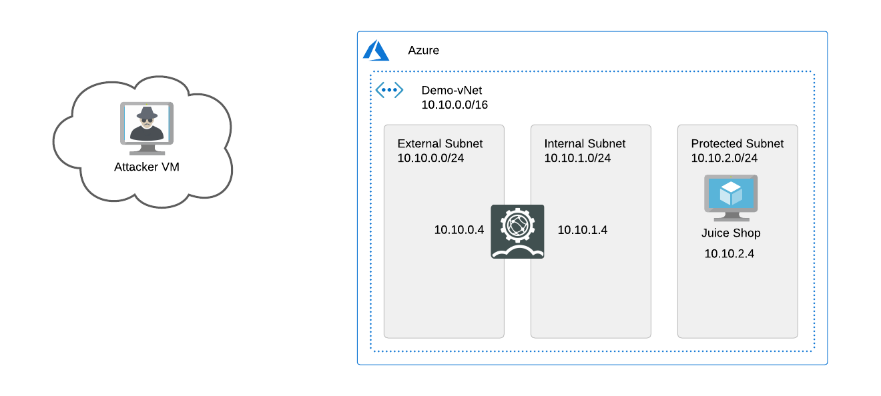

**Initial Configuration/Setup:**

1. Connect to Fortiweb by using the IP address corresponding to the Lab number assigned to you.

<https://ipaddress:8443>

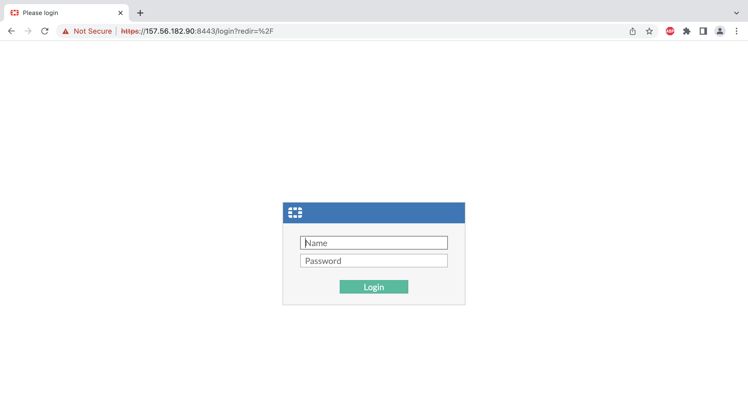

2. The credentials will be provided during the lab time. Please login to the lab using those credentials.

**username**: azureuser

**password**: Password123!!

Once you login you will be at the dashboard.

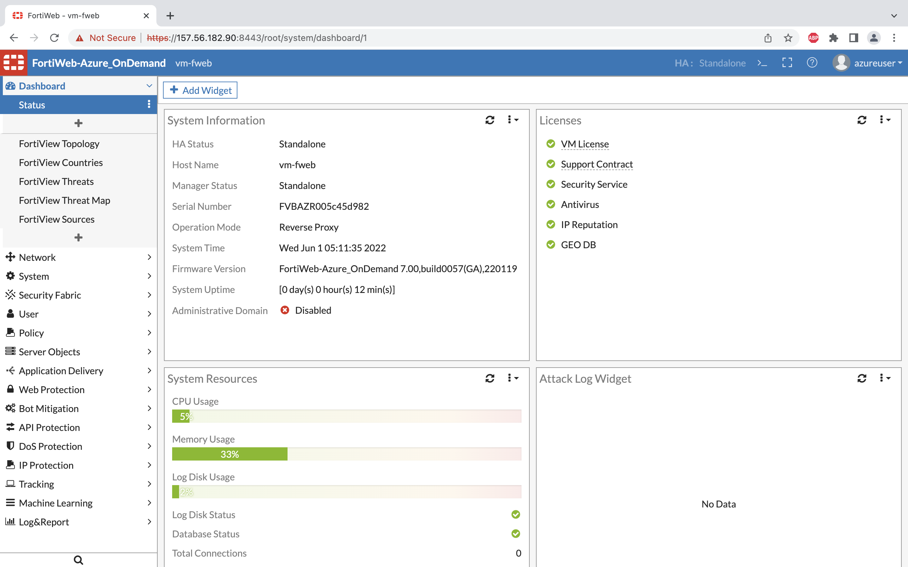

3. Click on CLI Console to check the connectivity to the web server.

Execute ping 10.10.2.4

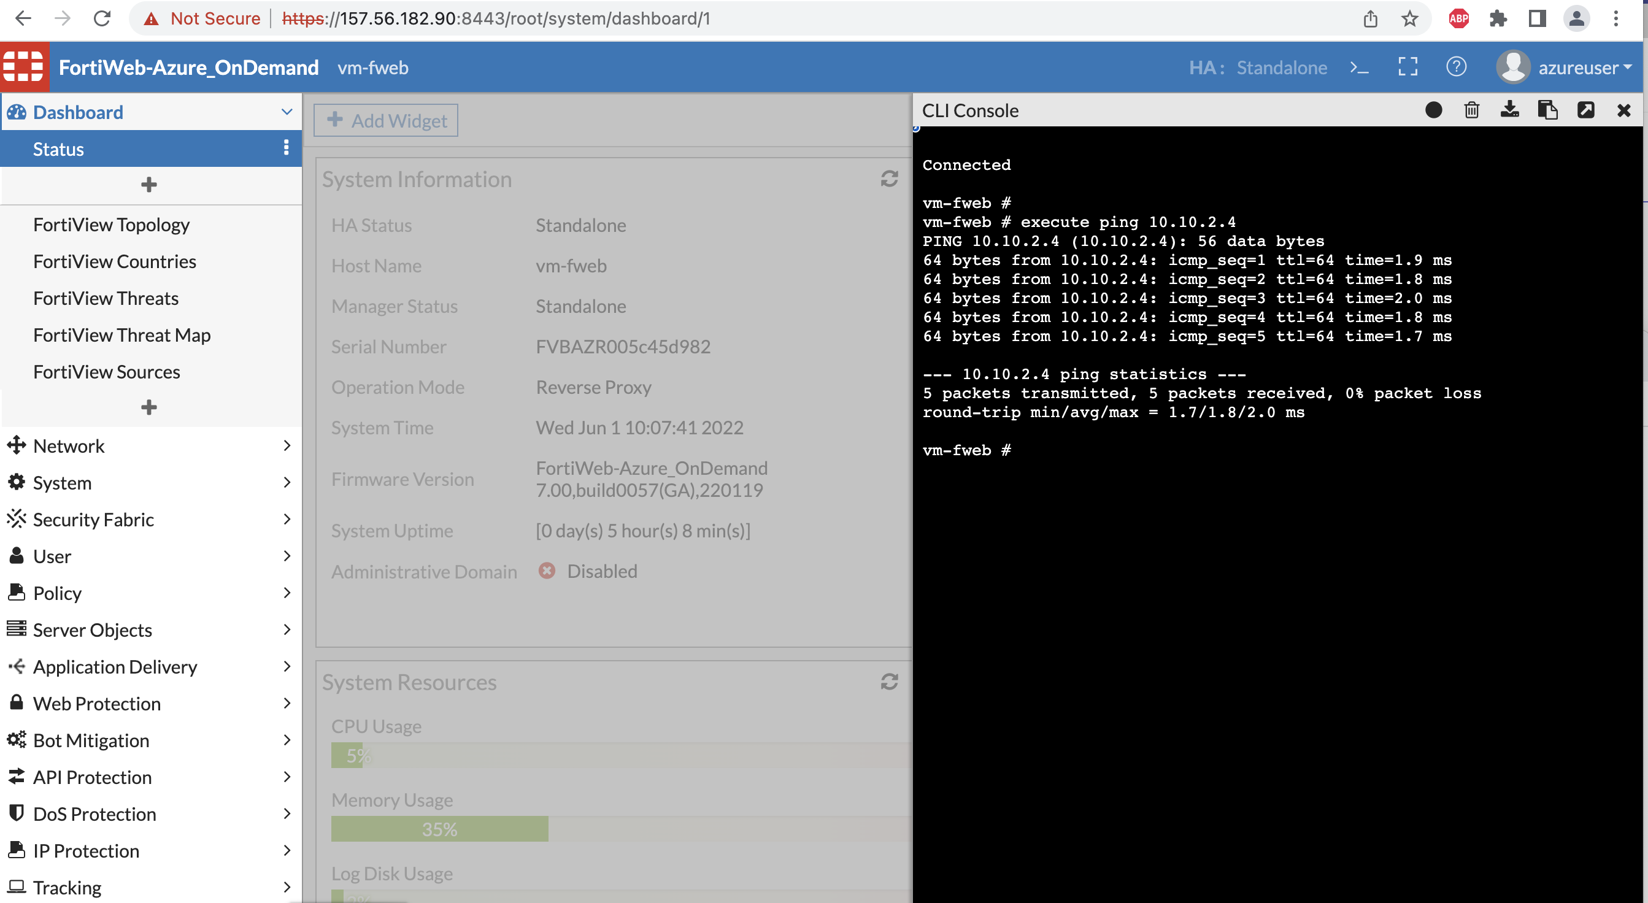

4. The application is hosted on a docker container which is up and running on Ubuntu server. We need to create the Server object for Fortiweb to send the traffic to application server.

Navigate to Server Objects >> Server >> Server Pool >> Create new

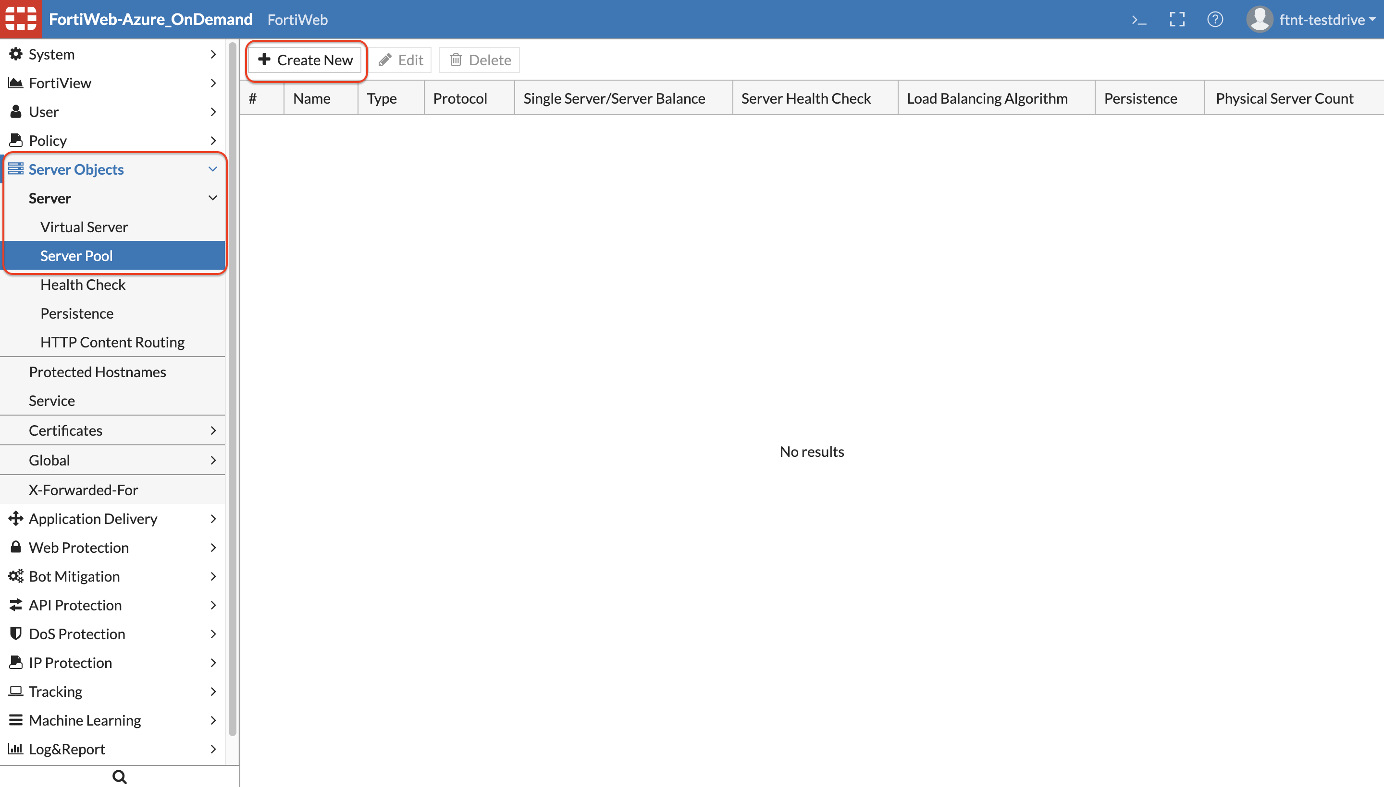

5. Input information as shown below. Select the Server Balance option for Server Health check option to appear. Click OK.

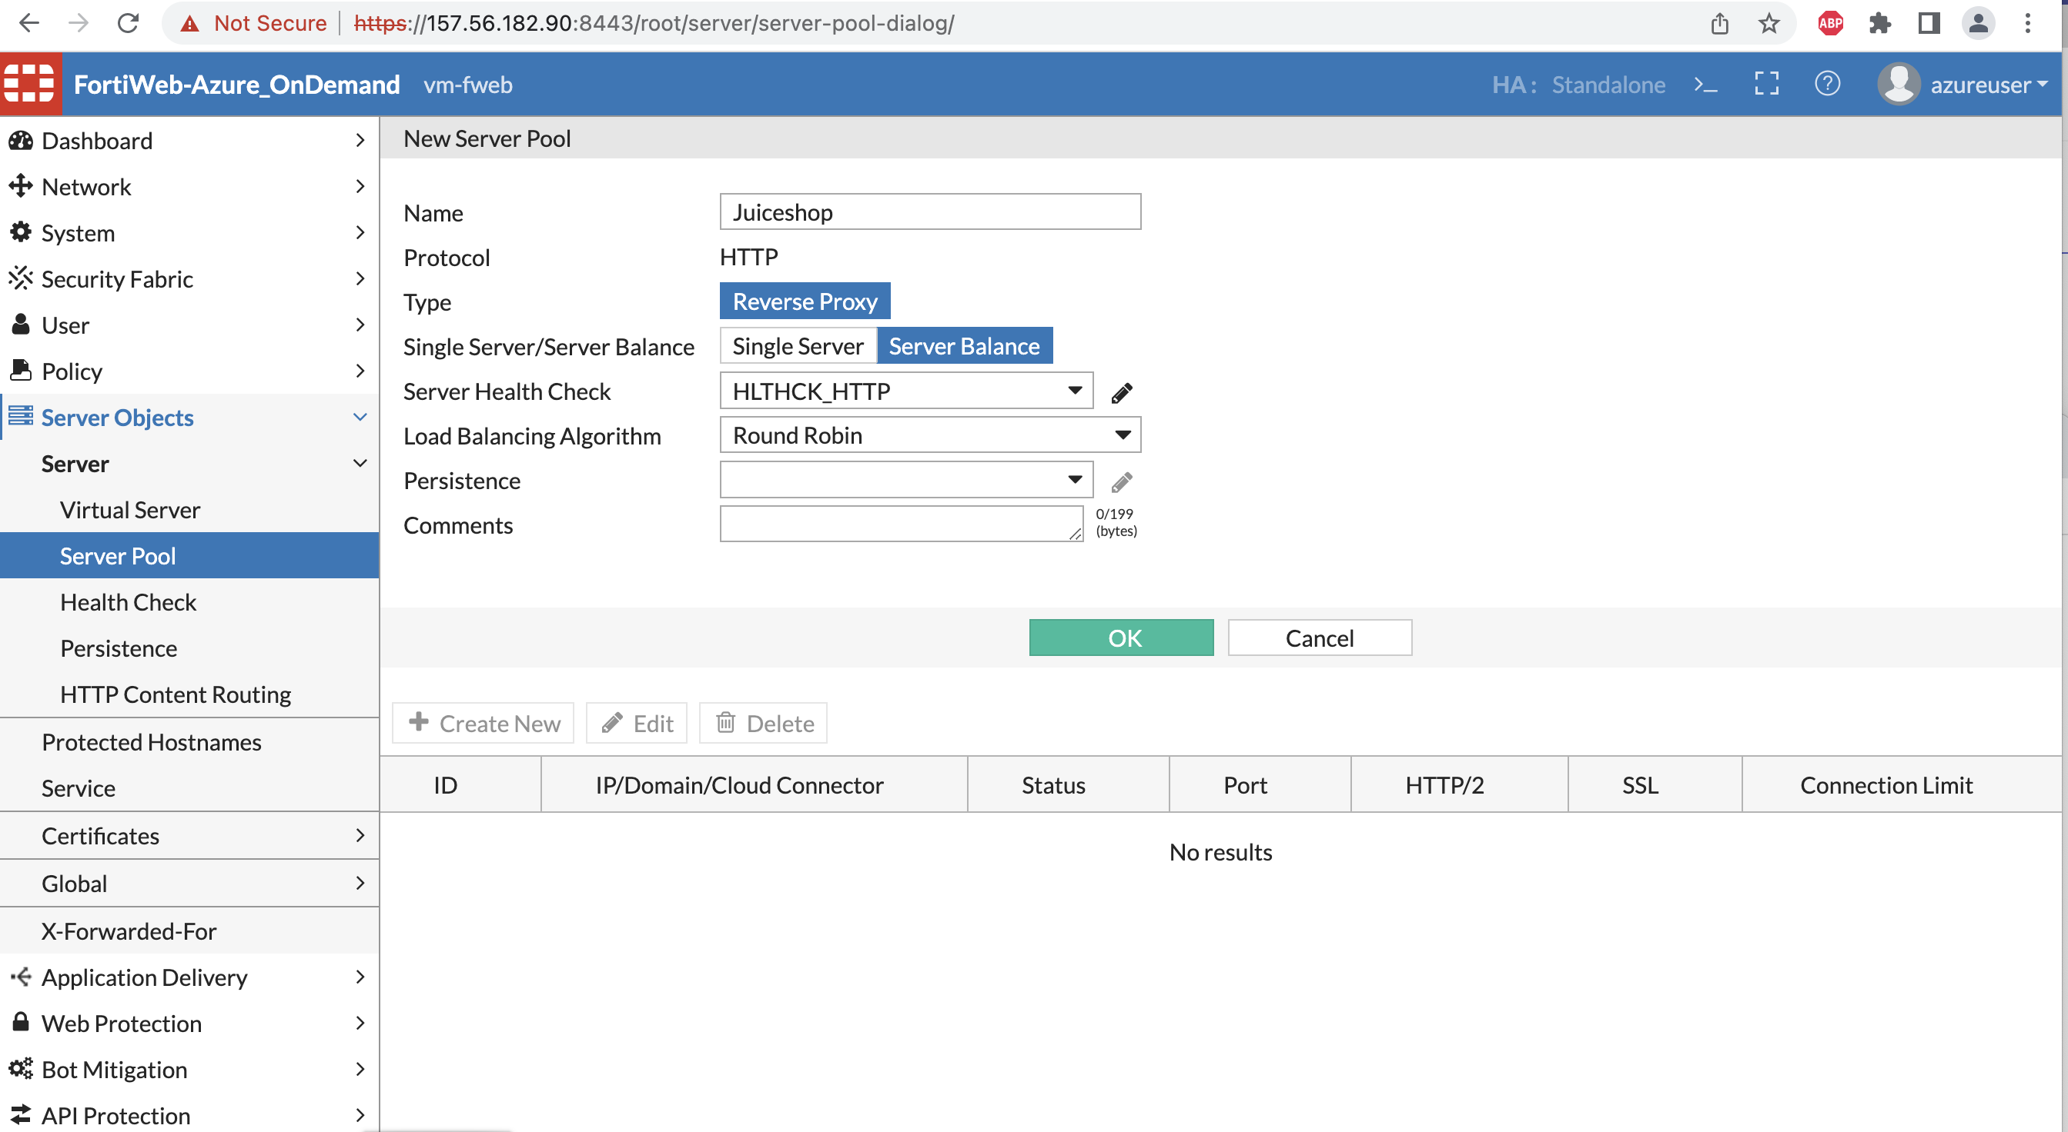

6. Once click OK in the above step the greyed out Create new button should now appear to create the Server object.

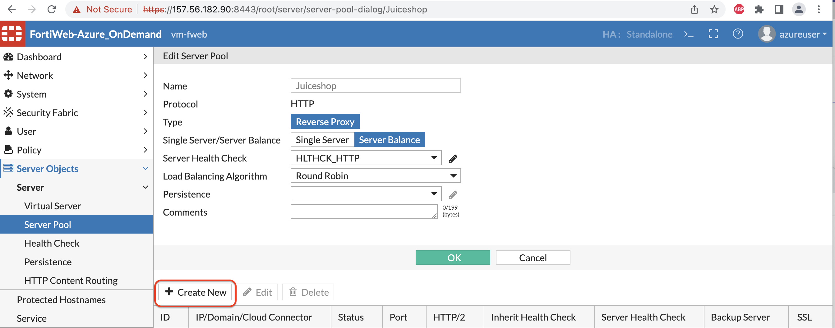

7. Now enter the IP address of your application server, port number the pool member/application server listens for connections. In this case the docker container for juice shop is listening on port 3000.

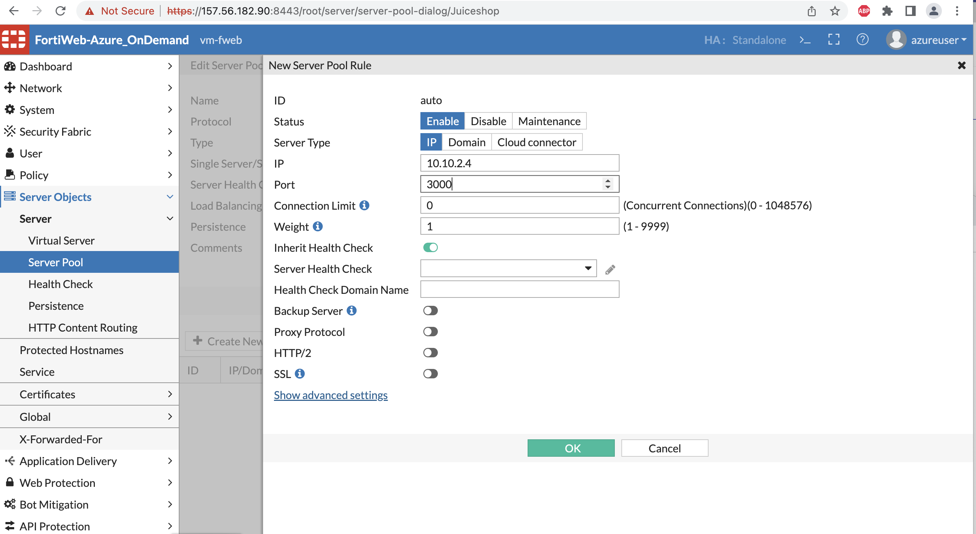

Click OK once you enter the information.

8. Now we will need to create the Virtual Server IP on which the Traffic destined for server pool member arrives. When FortiWeb receives traffic destined for a Virtual server it can then forward to its pool members.

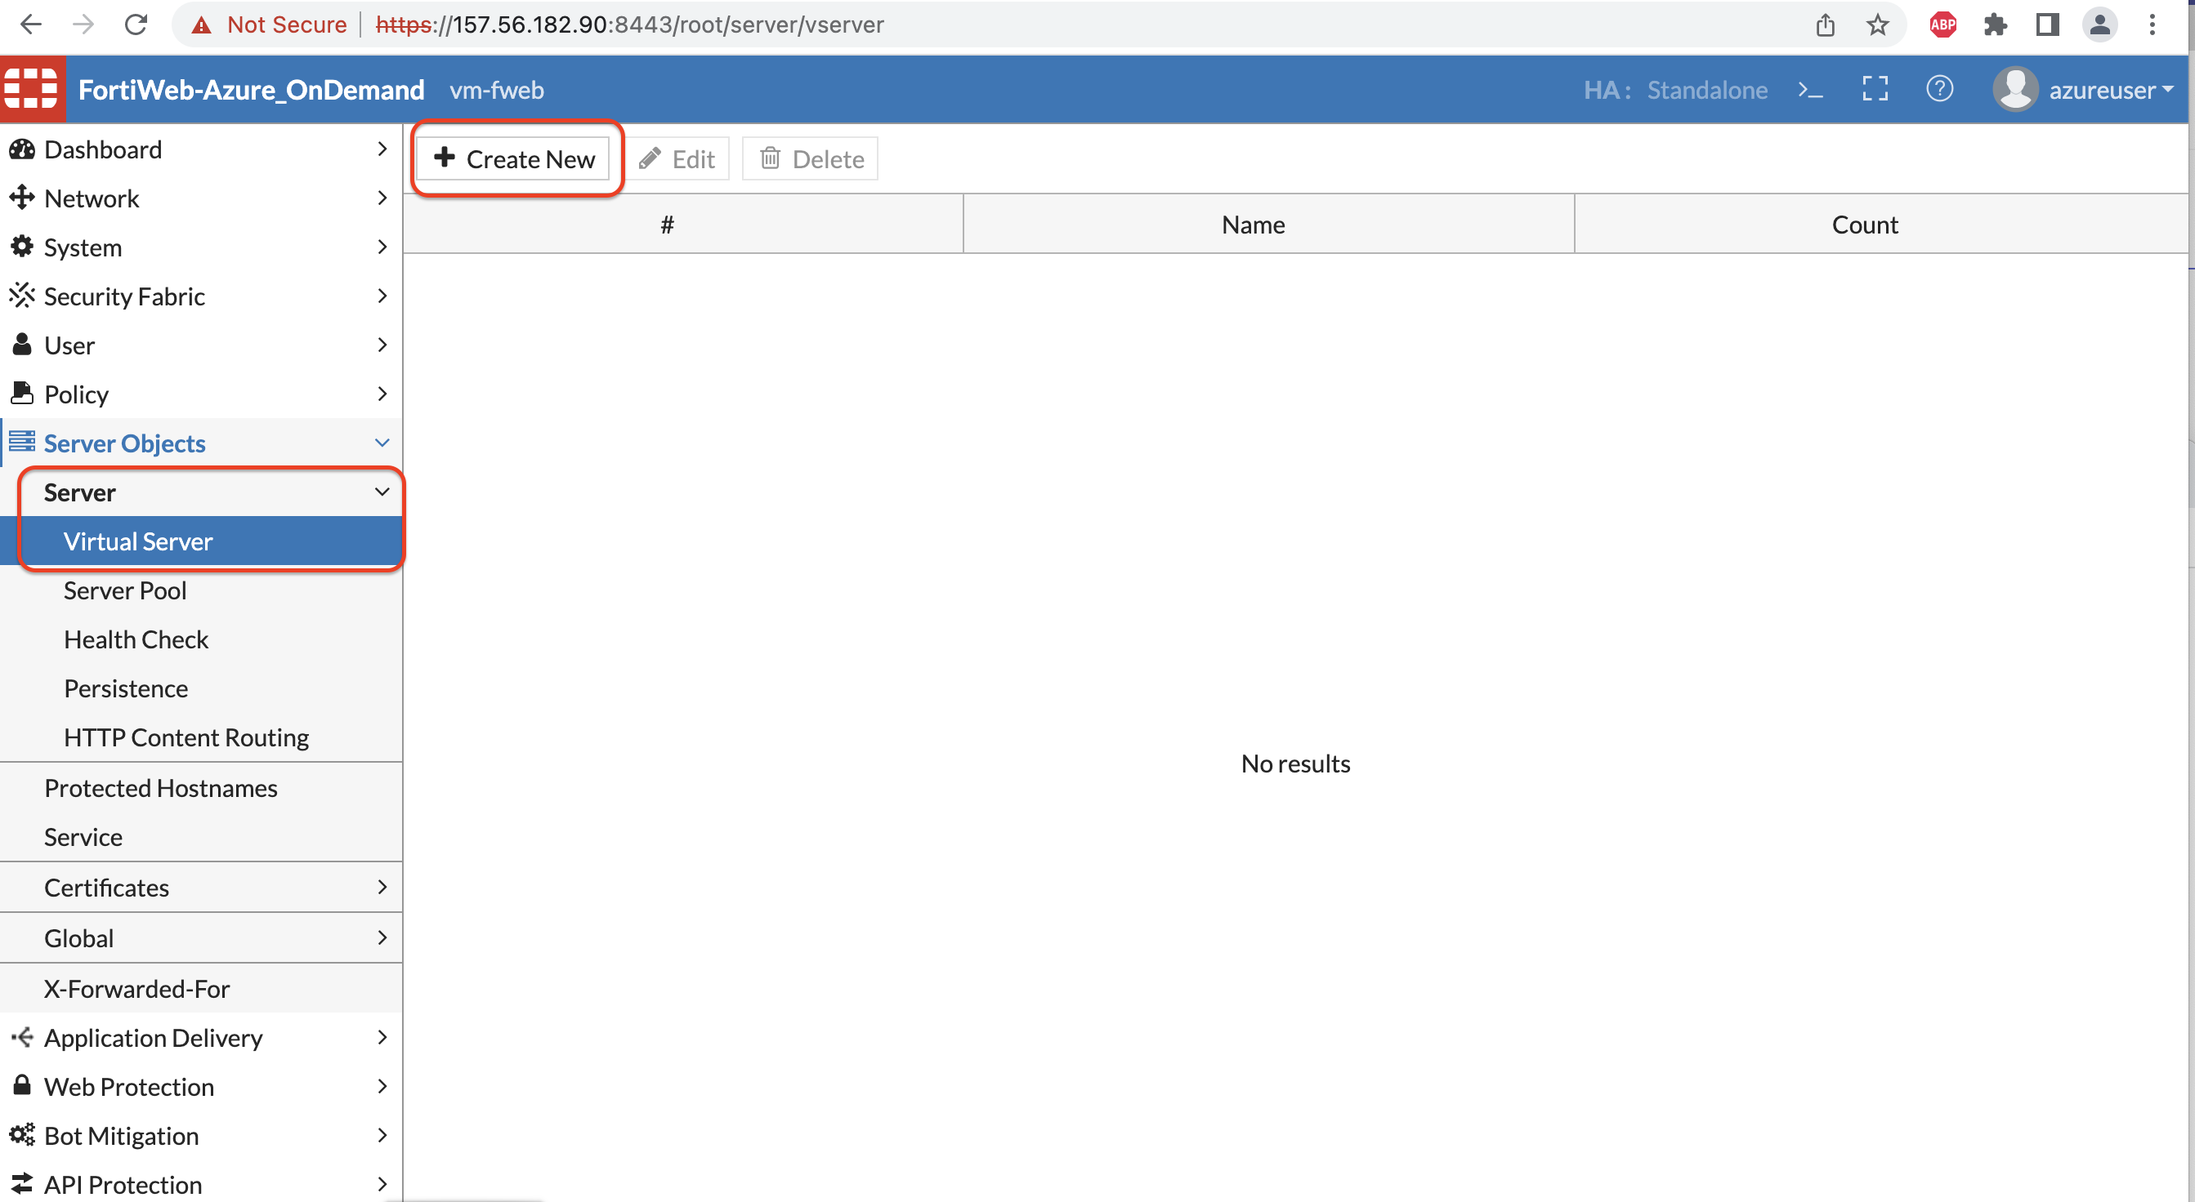

9. Enter the name for the Virtual Server and click OK. You can now click Create New to create the VIP object.

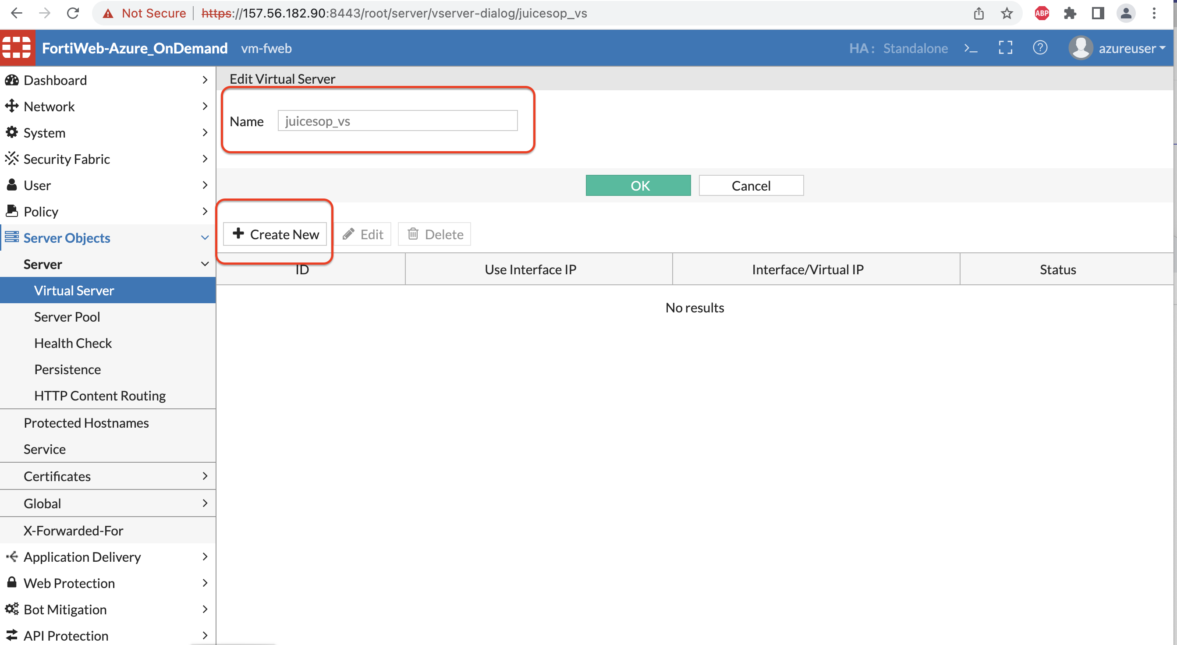

10. Virtual Server item can be an IP address of the interface or an IP other than the interface. In this case we will use the interface IP - Turn on the Radio button for “use interface IP”, a drop down with interfaces will appear. Select Port1 as the interface for this Virtual Server item and click OK.

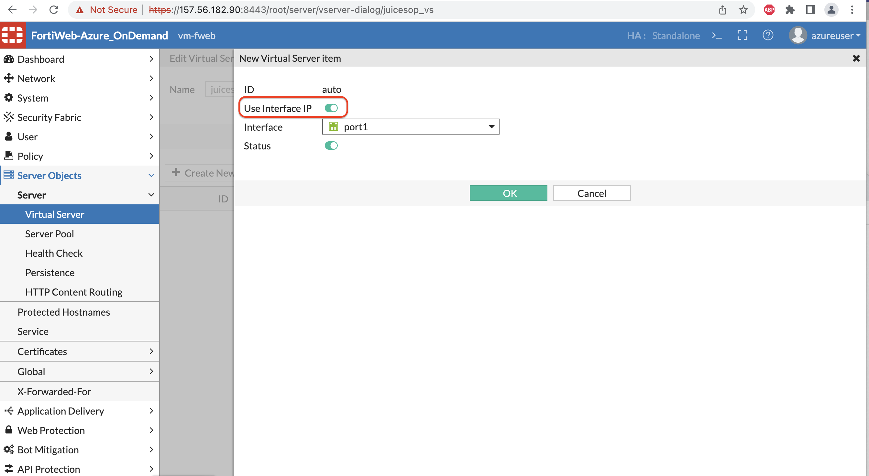

11. The Virtual Server for the Juice shop app is now using the IP address of the Port1 Interface.

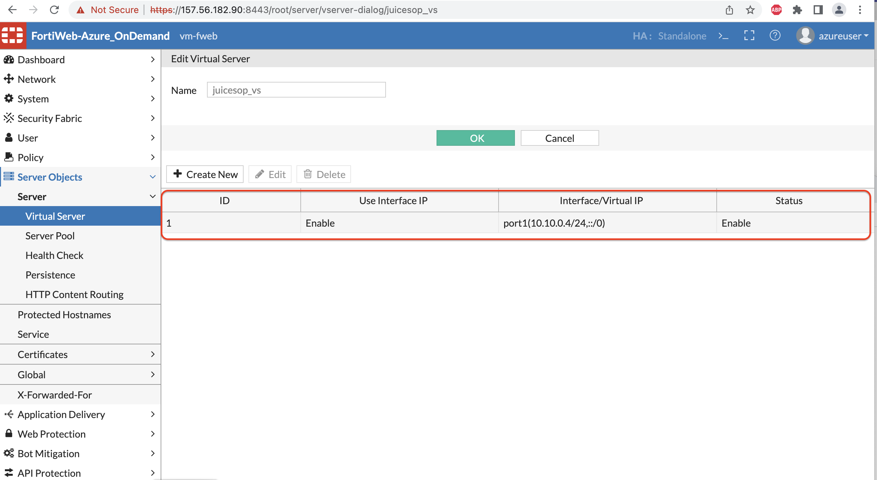

12. We will now create a custom protection profile which we will be using in the Server policy to protect the application Server.

Navigate to Policy >> Web Protection Profile 🡪 click on Inline Standard protection >> Click Clone

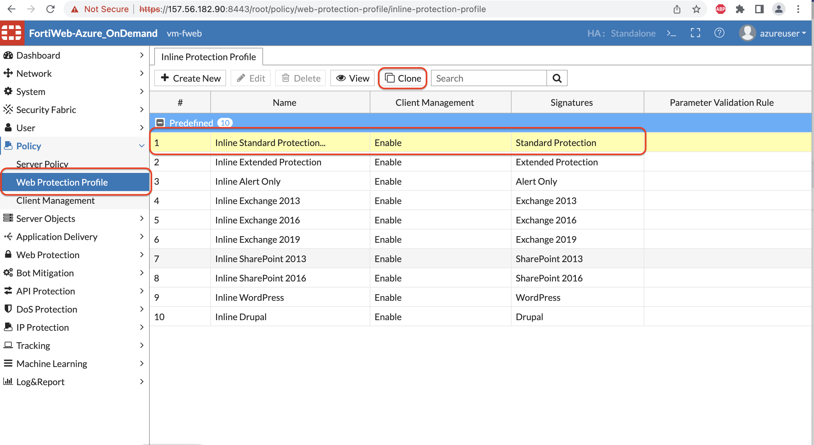

13. Create a custom Protection profile for juice shop, you can give a name of your choice.

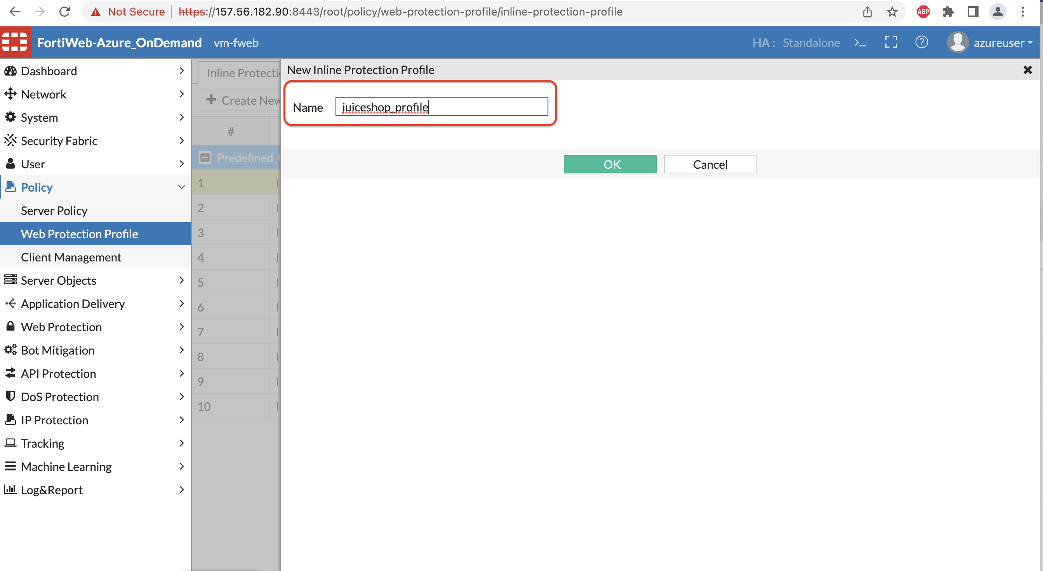

14. Now let’s create a Server policy. Input Name for the server policy, Select the Virtual Server, Server pool which we created in the earlier steps from the drop down.

For the HTTP Service, Click **create new**

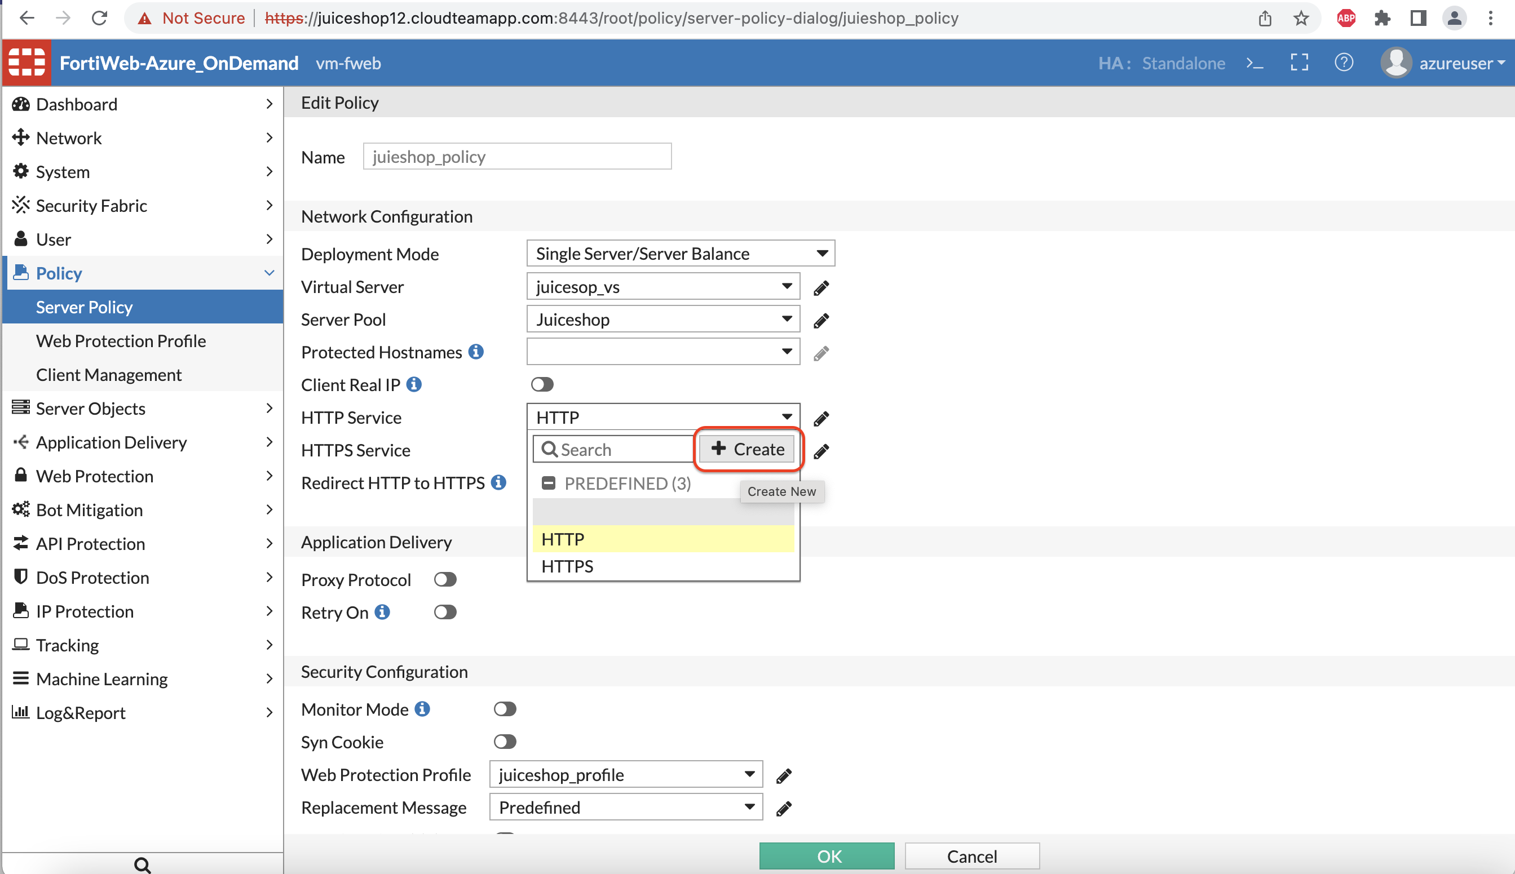

15. Enter the port number the Virtual Server traffic will be reached on. Let’s keep this to 3000. **(Note: You can set up any port here or even can use HTTP/HTTPS. To make it easy for the rest of the lab use Port 3000)**

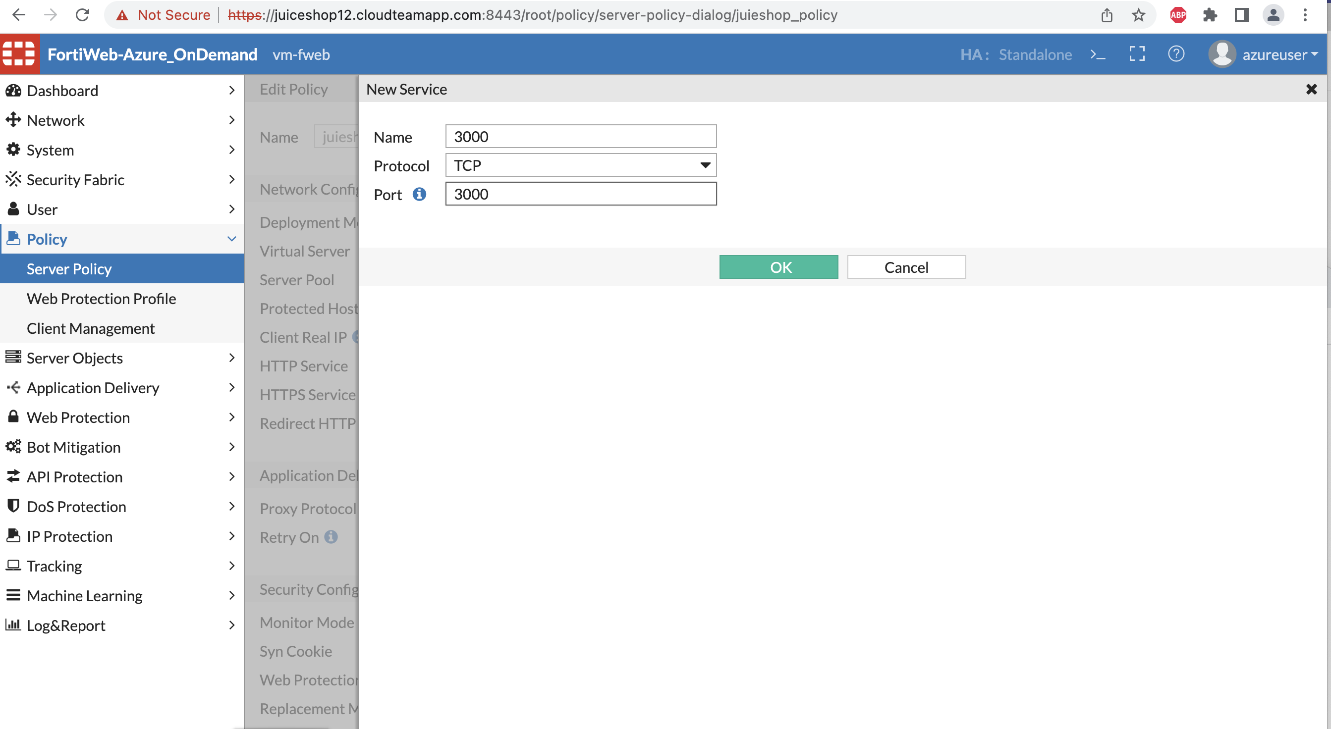

16. Now let’s attach the protection profile you created in the earlier steps and click OK.

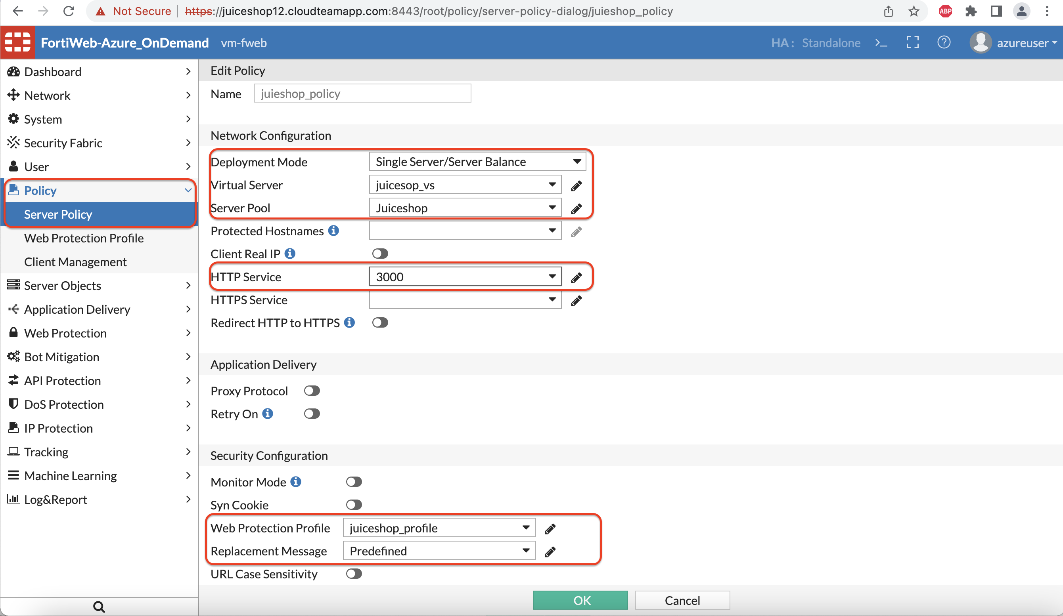

17. Now let’s Navigate to the browser and type the Public IP assigned to your FortiWeb instance to get to the web browser.

<http://FortiWebIP:3000>

For example: http://157.56.182.90:3000

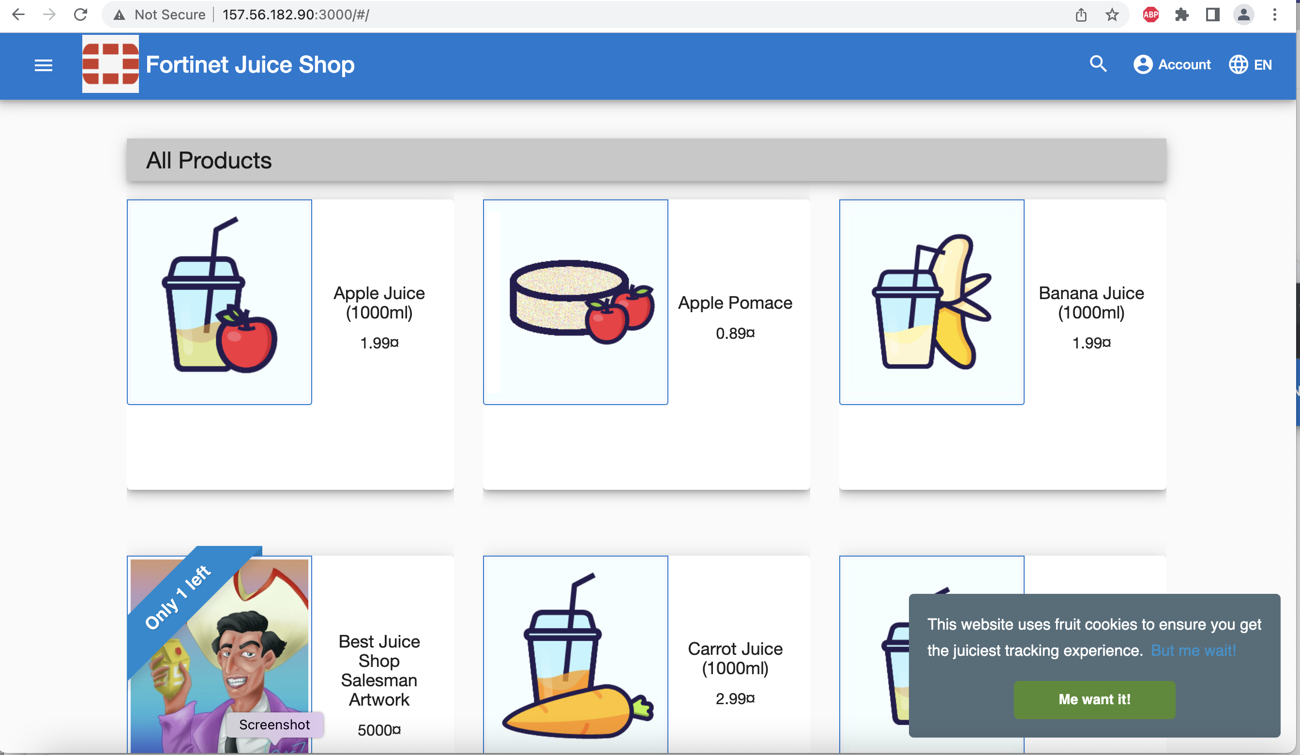

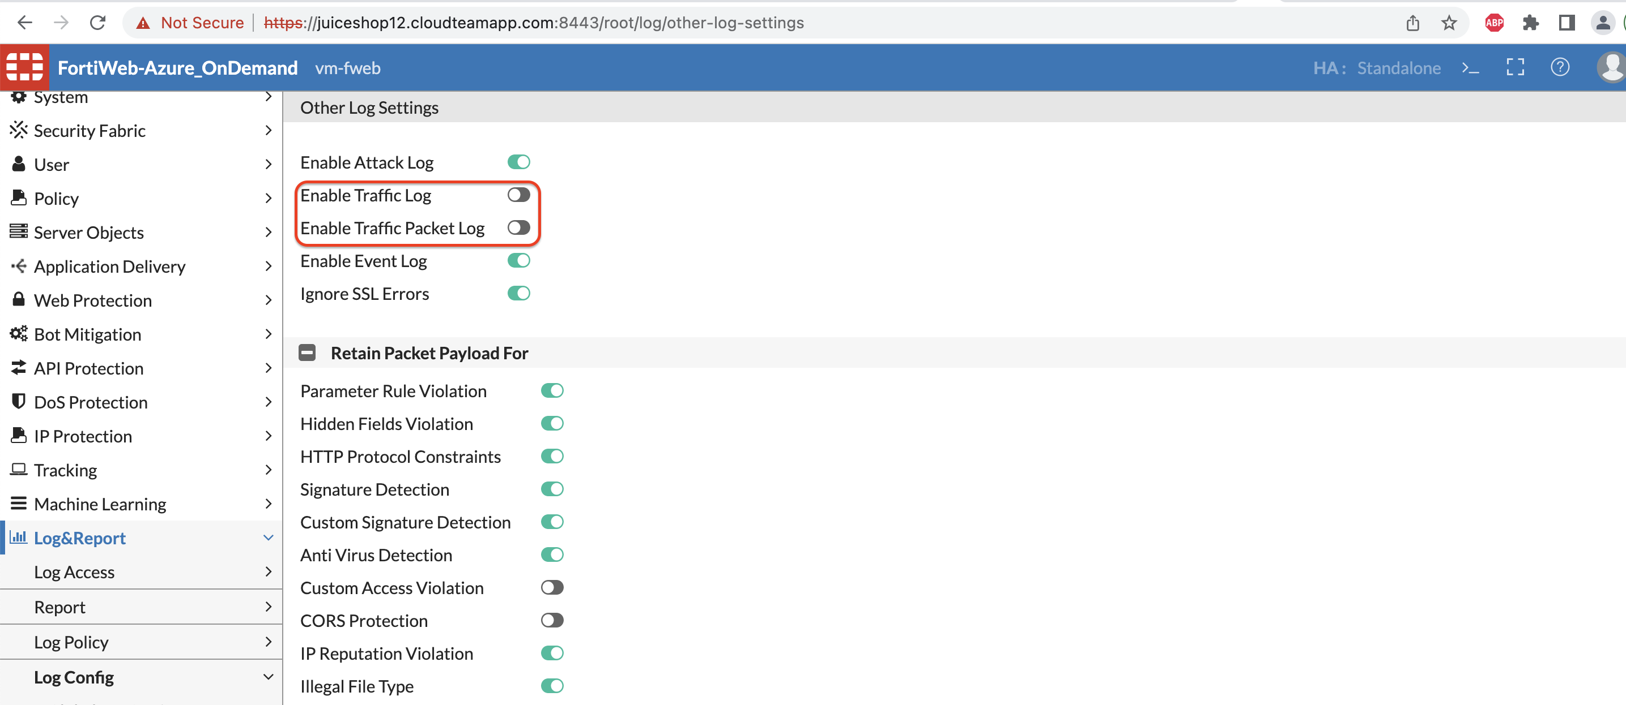

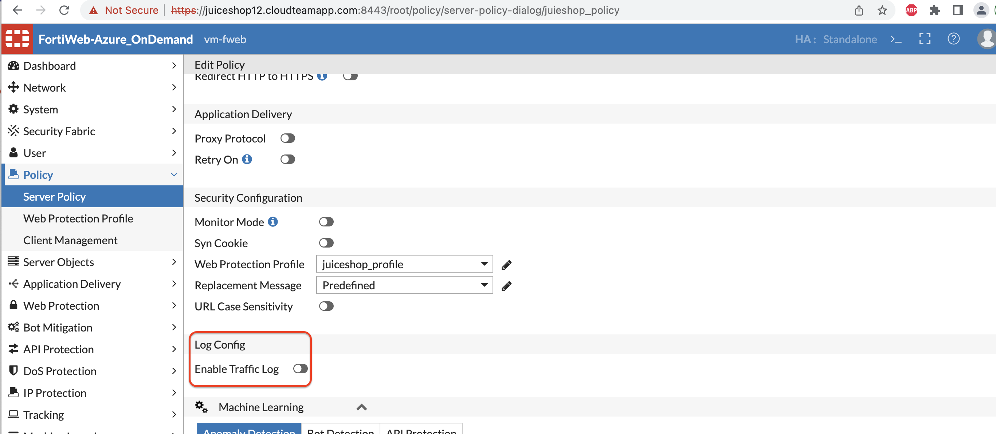

Now for Machine Learning to collect the samples we would need a domain name for this Web application. The Domain names are already configured resolving to the public IP address of the Fortiweb.

The domain name for your application would be <http://juiceshopX.cloudteamapp.com:3000> (X is the Lab number assigned to you)

Make sure you can reach to your juice shop through FQDN as well.

Once you have confirmed let’s proceed to the next Lab.

Attack 1

[DEFENSE]

**Biometrics based bot detection:**

Now let’s see how FortiWeb will protect the Juice shop from the Bot you ran during the attack module.

1. Create a Biometrics based Bot detection by clicking create new as shown below:

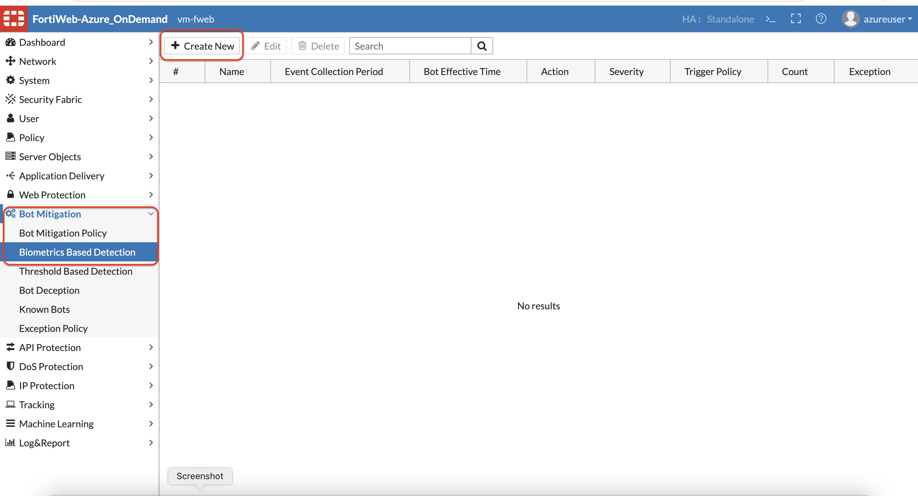

1. We can monitor for Various client events as shown below. However lets uncheck the default values and only select Screen Touch for now.

Also change the event collection period to 10 seconds. Fortiweb will monitor the client activities for 10 seconds before it confirms the client is a bot.

Click OK.

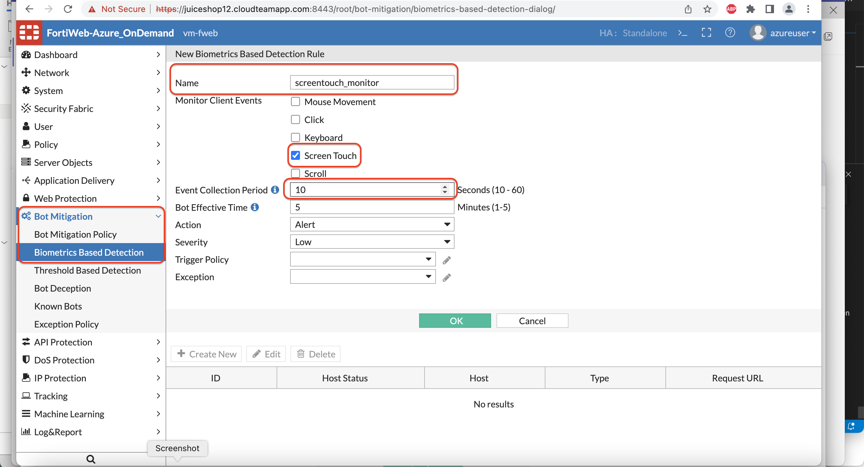

1. Click Create New for the URL Fortiweb will monitor these events on.

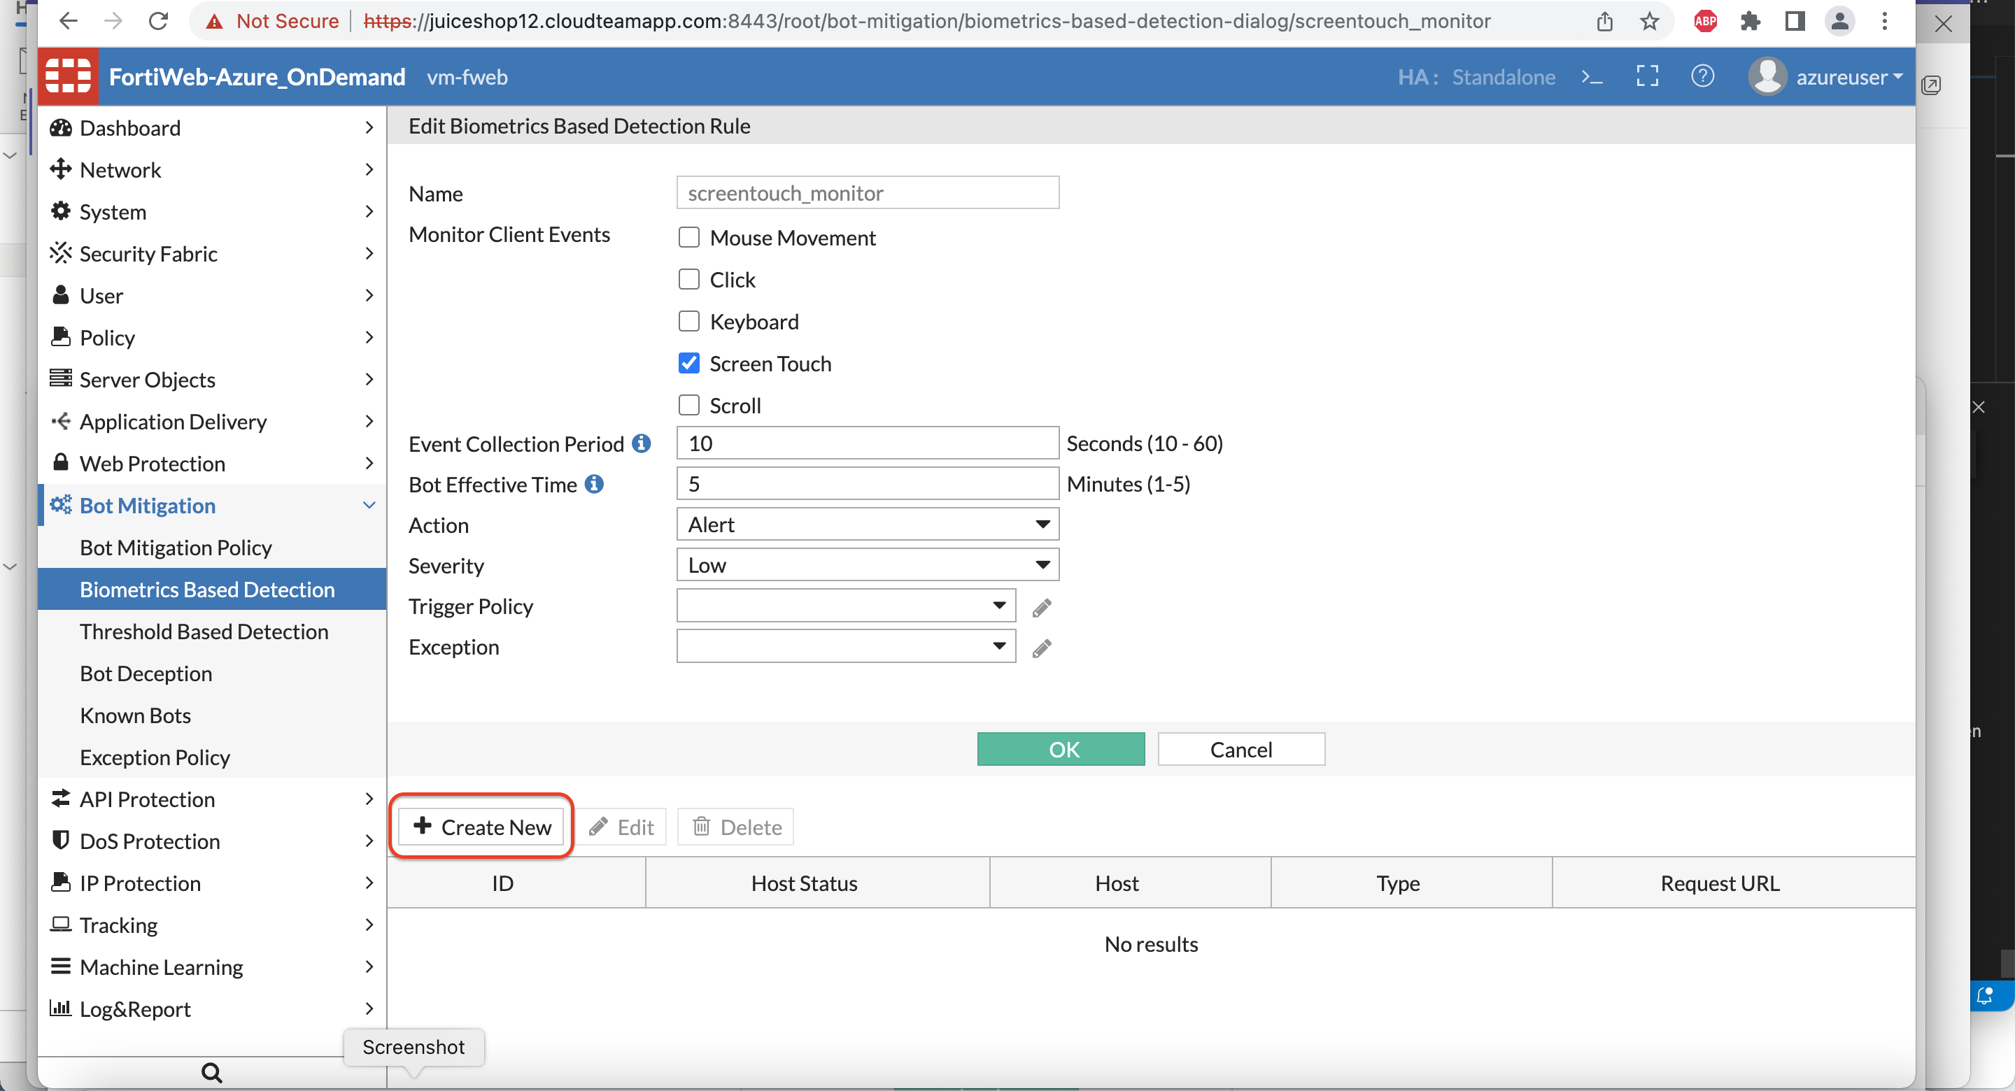

1. Select Regular expression, and **.\*** to match all the URL’s.

Click OK.

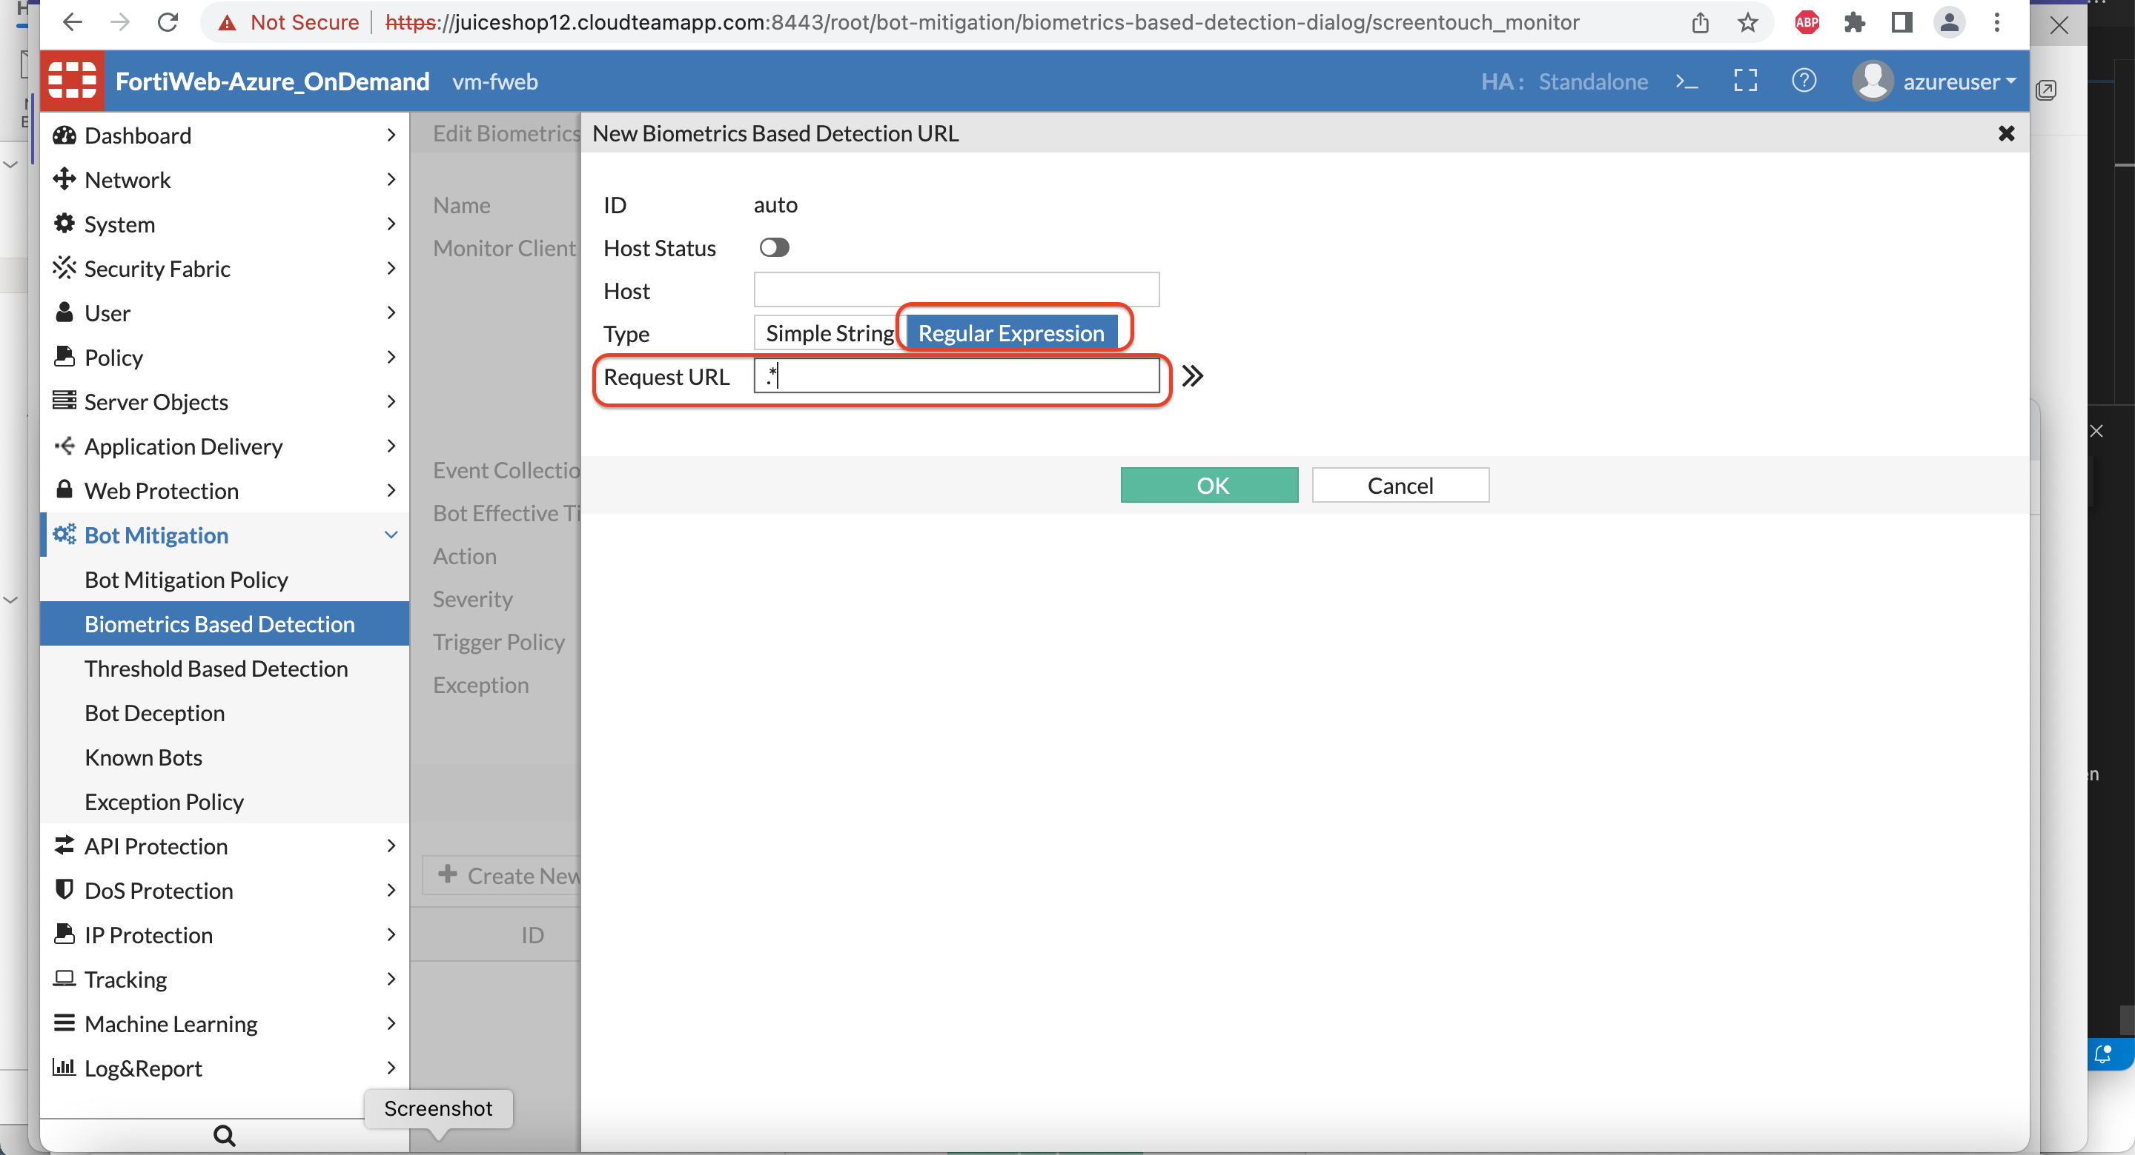

1. Now Let’s create a Bot Mitigation Policy and attach the Bio metrics-based bot detection rule which we created in the earlier step.

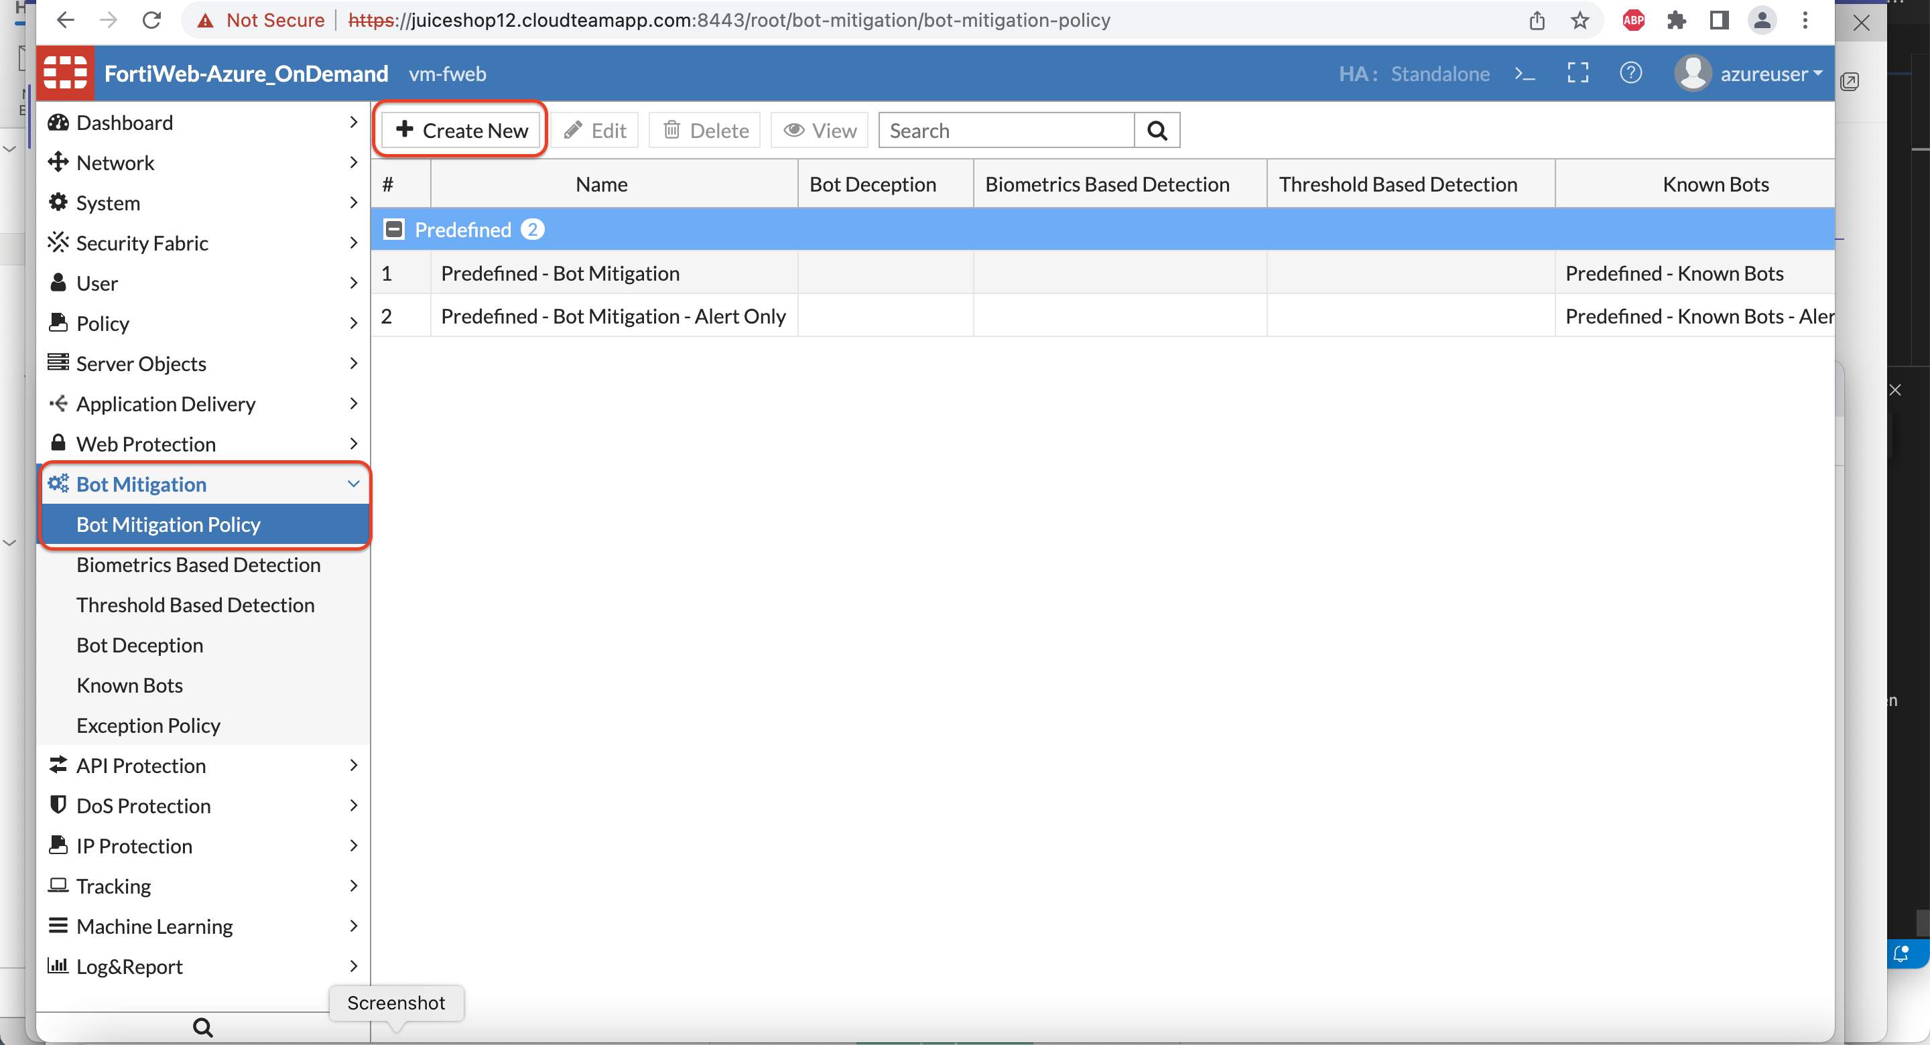

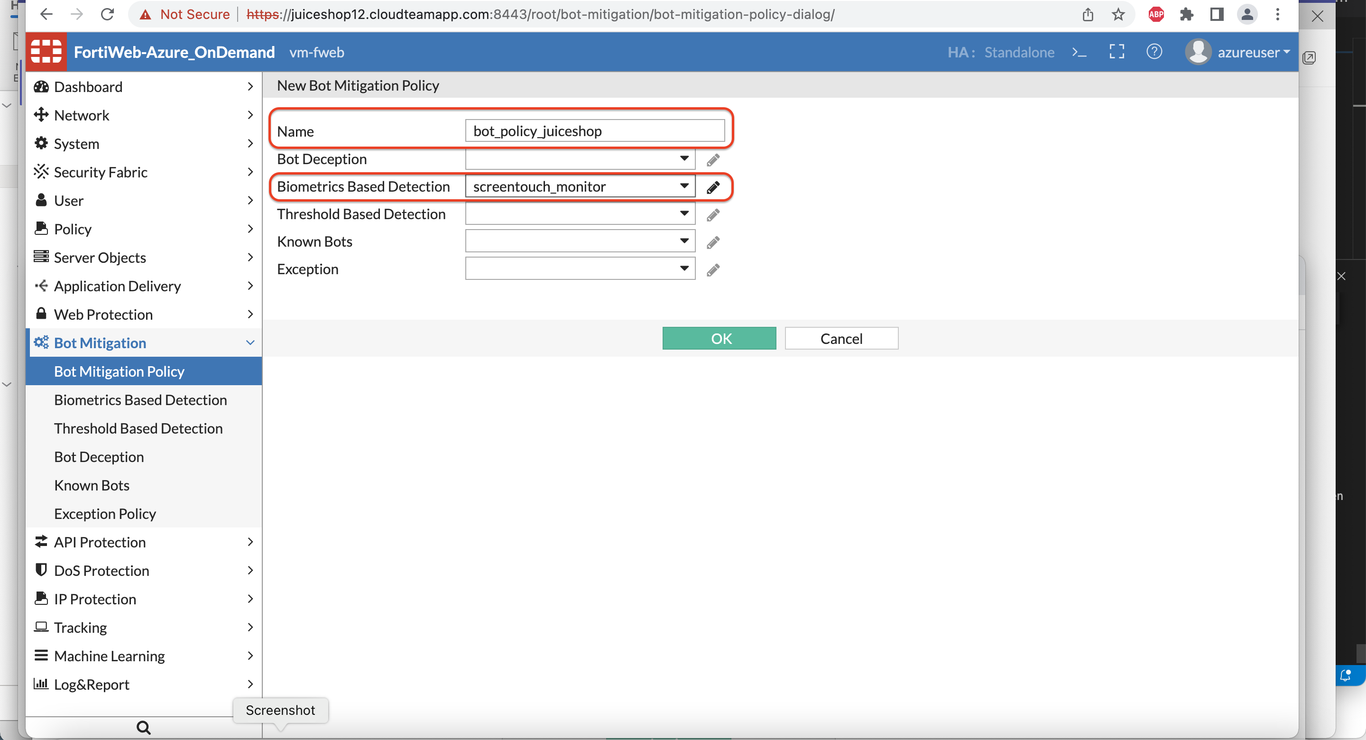

1. To apply this to the Juice Shop protection profile, Navigate to Policy >> Web protection profile >> click the juiceshop profile we create earlier.

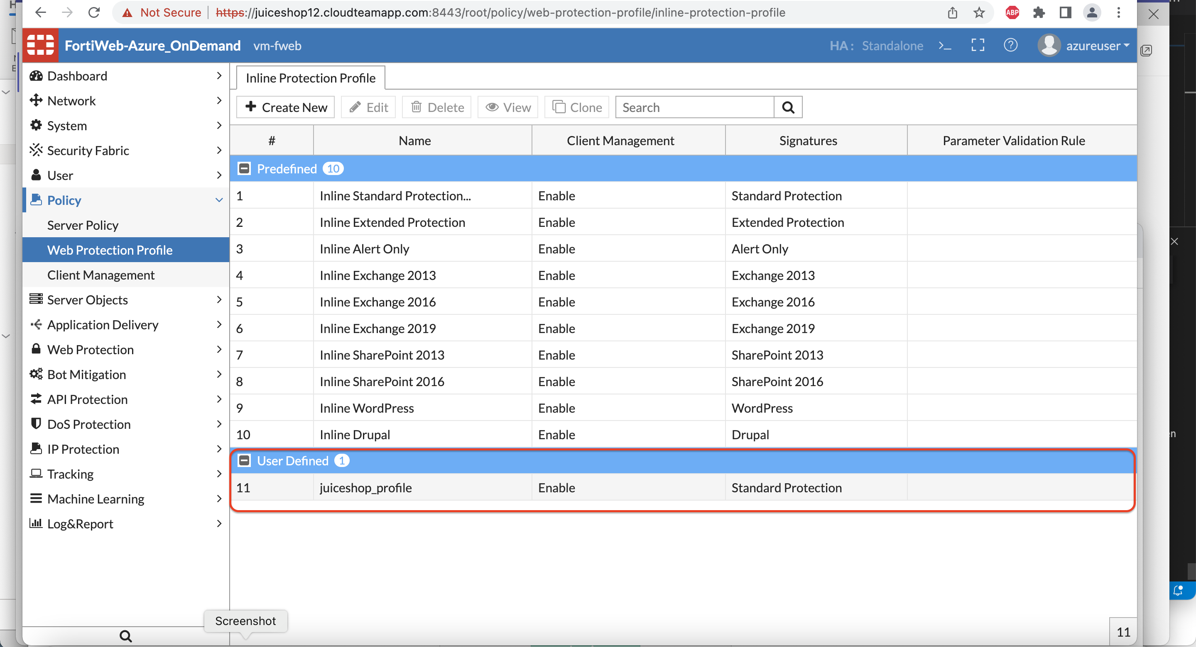

1. Scroll to Bot Mitigation and assign the policy we created in Step 5.

Click OK.

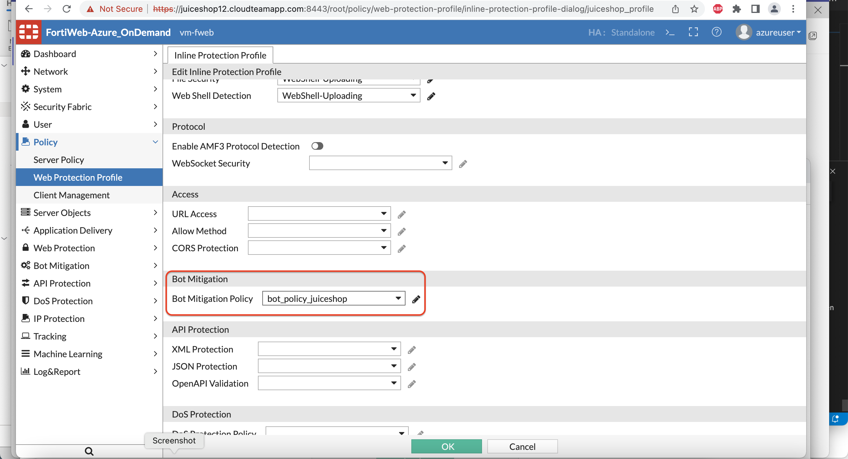

8 ) Repeat the same steps from attack lab to run the bot again:

After 10 seconds the bot will crash with a crash log on the terminal.

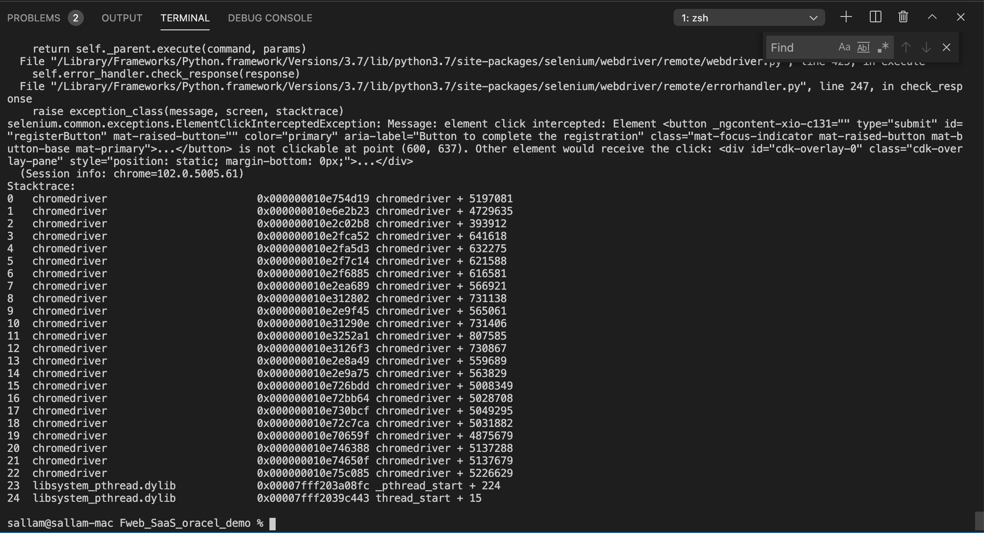

1. On Fortiweb if you go to Log >> log and report >> attack log:

You should see an attack log generated for Biometrics based bot detection.

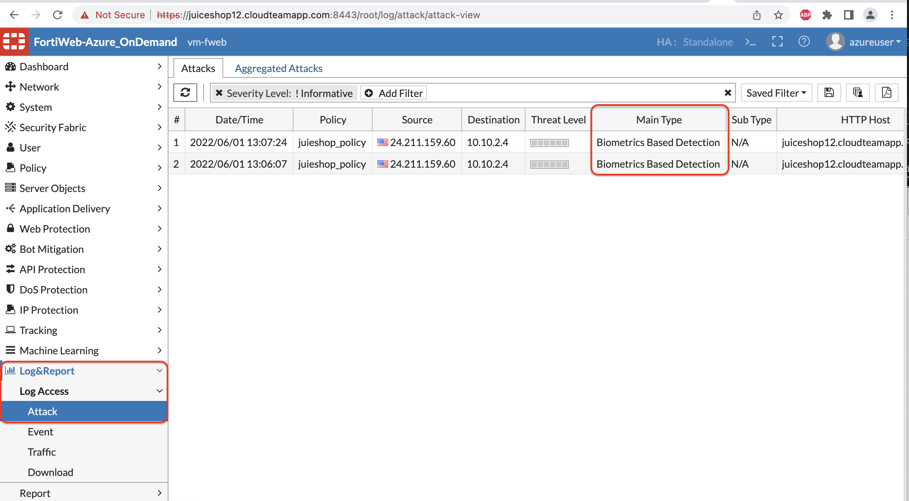

1. Double click on the log to see a Message with the explanation.

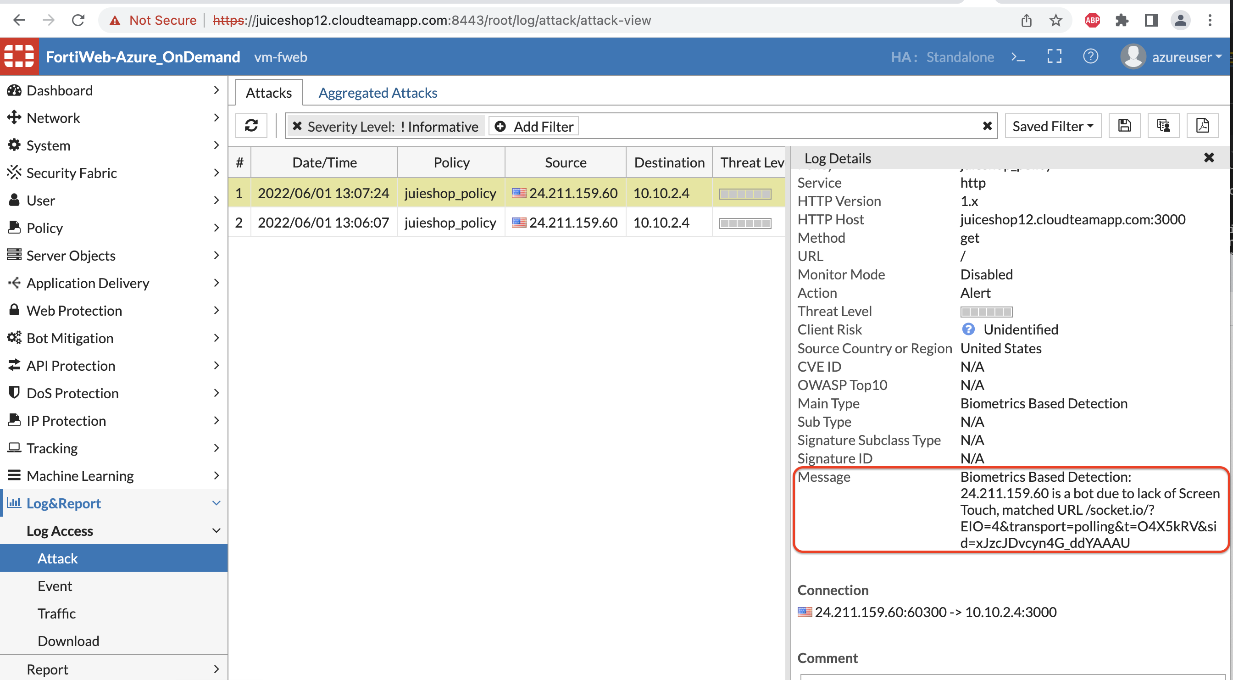

That concludes the Biometrics based bot detection lab.

**Anomaly Detection – Defend using ML on FWEB**

1. To configure Anomaly Detection, Go to Server Policy >> Double click the existing policy and scroll down to Machine Learning.

Let’s start with AD ML. Click Create

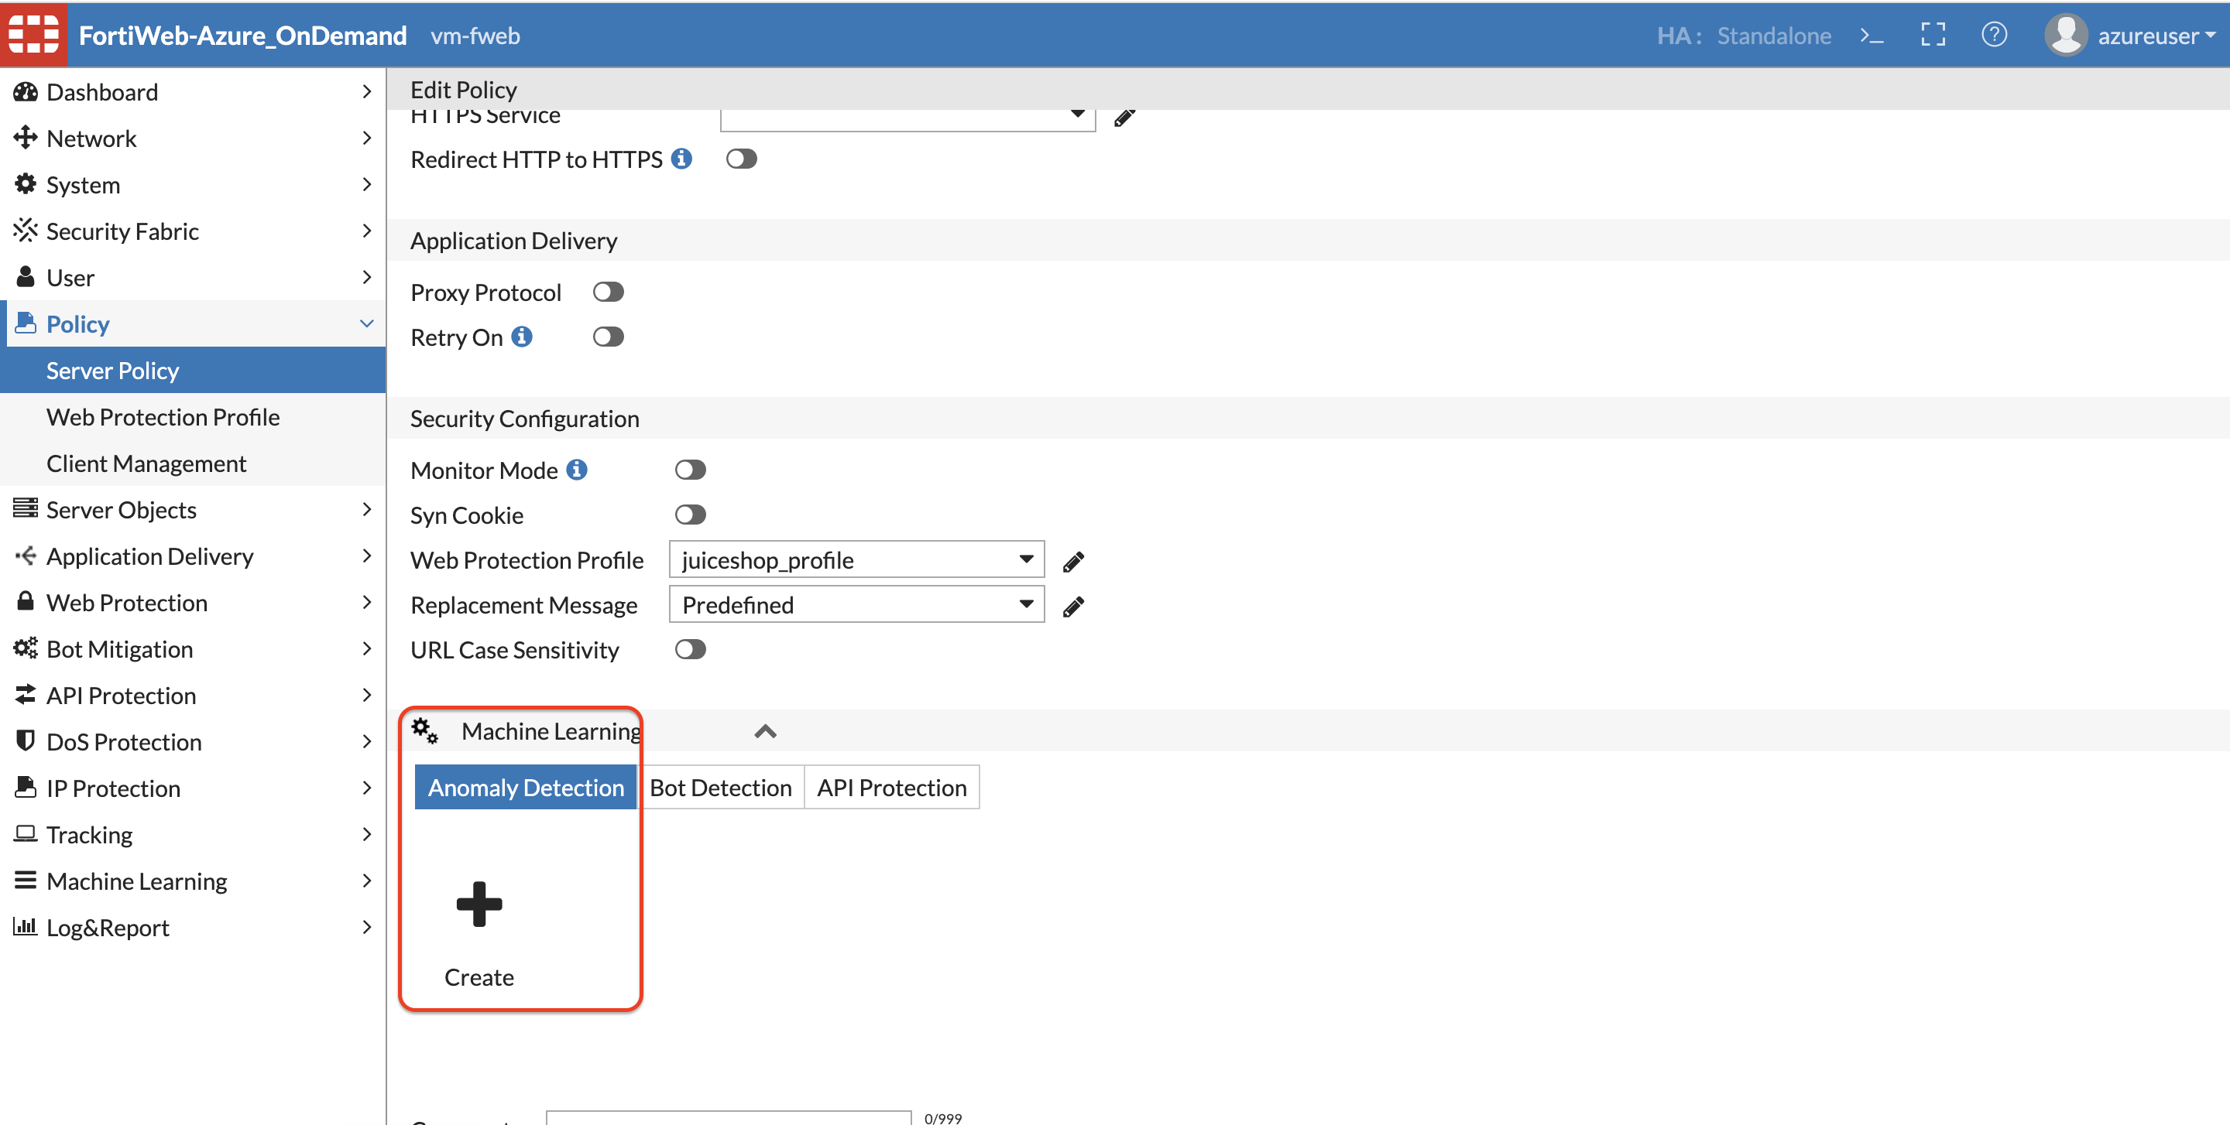

1. You will need to enter the domain name here for the juiceshop. This domain name will be juiceshopX.cloudteamapp.com (X is the lab number assigned to you)

Click OK.

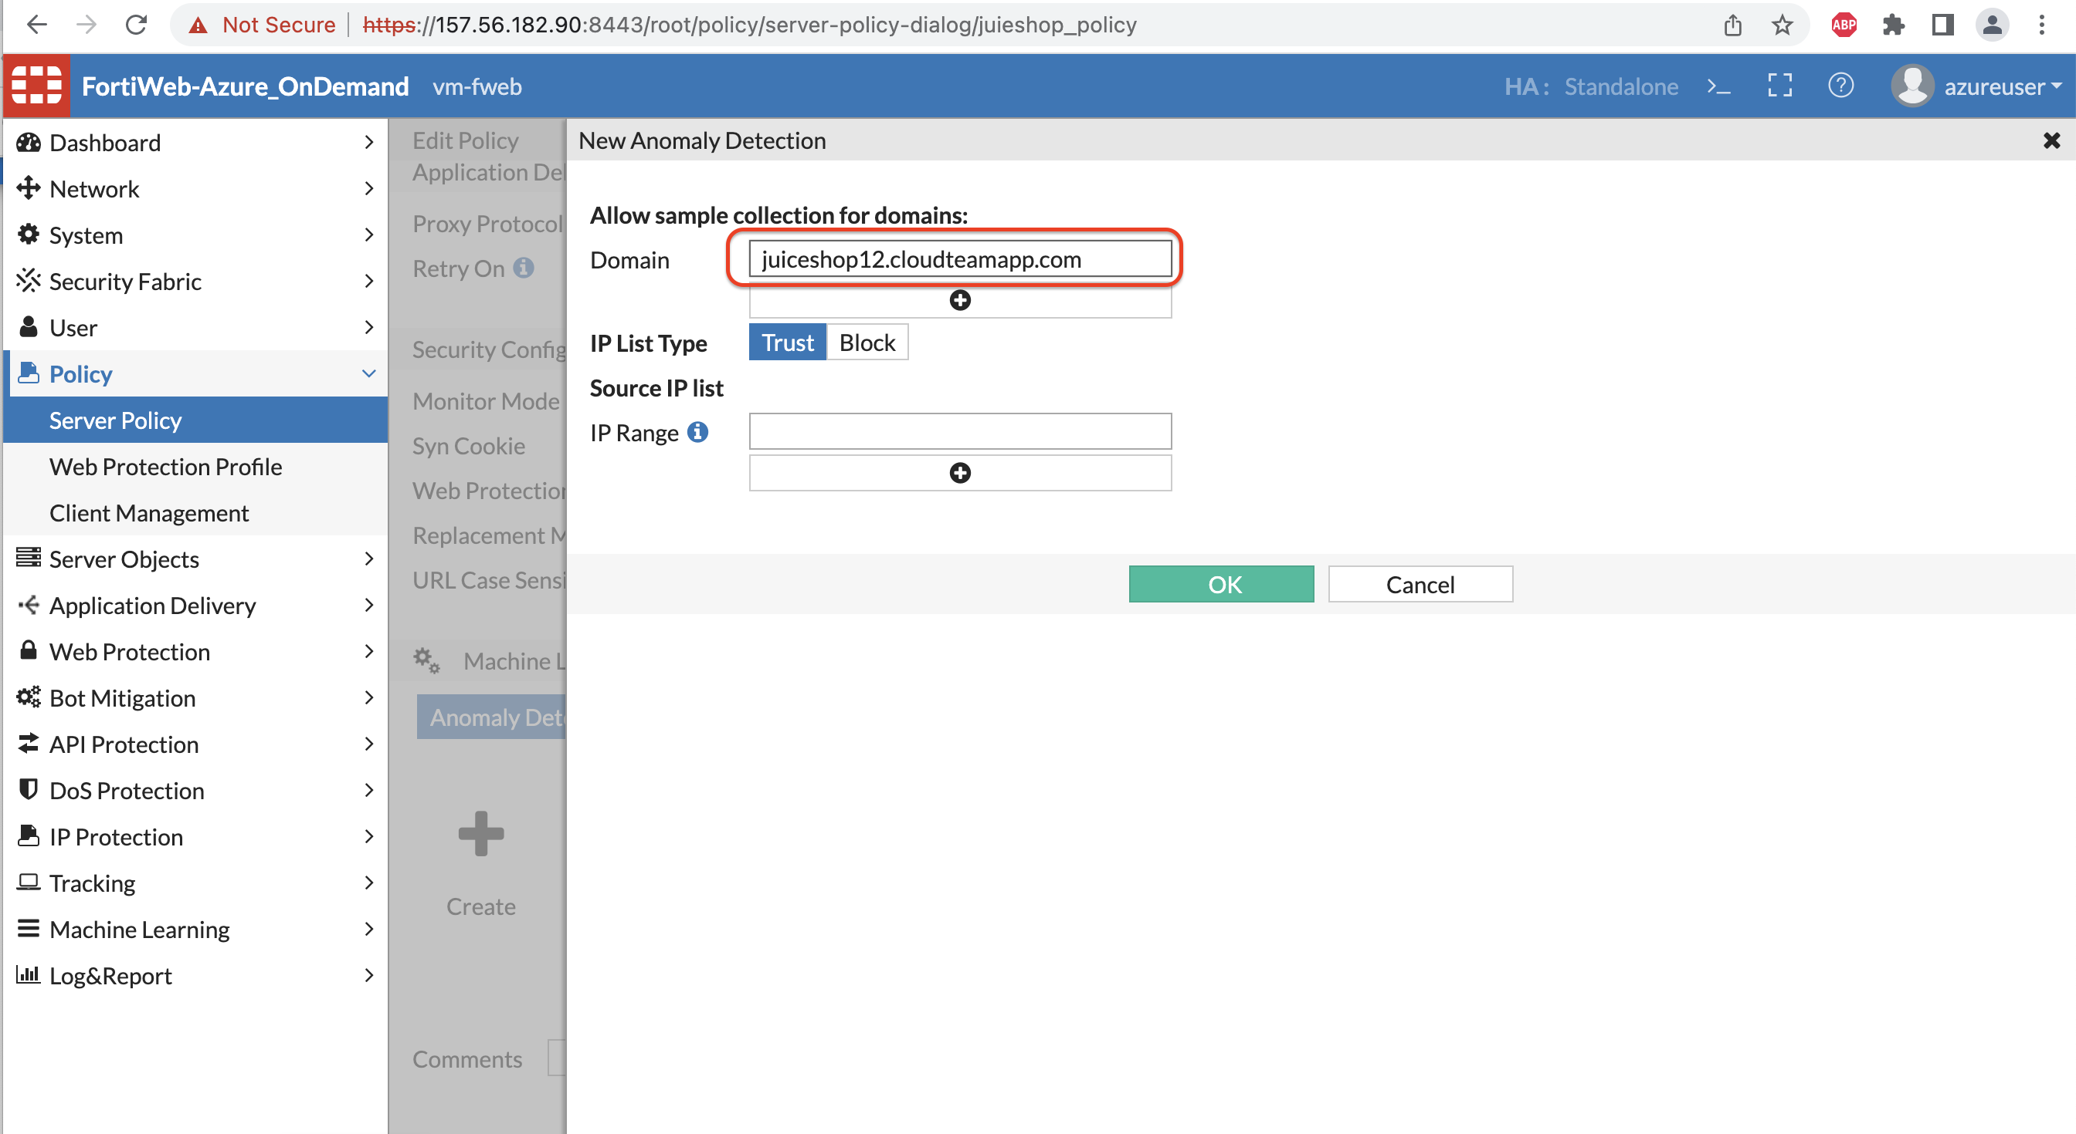

1. Click on CLI to Configure the create ML policy and to change values for the Machine learning Anomaly Detection.

We are doing this since Fortiweb default values are set for 30 samples to be collected from single IP address within 30 minutes. As we only have one IP from which we can teach the model let’s use the commands below and re-write the existing values.

config waf machine-learning-policy

edit 1

set sample-limit-by-ip 5000

set svm-type extended

set ip-expire-cnts 1

set anomaly-detection-threshold 1

end

|  |
| --- |
| config waf machine-learning-policy |
| edit 1 |
| set policy-id 6323951749903556134 |
| set sample-limit-by-ip 5000 |
| set svm-type extended |
| set svm-model xss sql-injection code-injection command-injection lfi-rfi common-injection remote-exploits |
| set anomaly-detection-threshold 1 |
| set ip-expire-cnts 1 |
| config allow-domain-name |
| edit 1 |
| set domain-name *.cloudteamapp.com |
| set domain-index 10039583444253572715 |
| next |
| end |
| set redis-server-host 127.0.0.1 |
| config source-ip-list |
| end |
| next |
| end |

1. Once you enter the domain name from Step 2 and click OK you should be able to see the icons below. 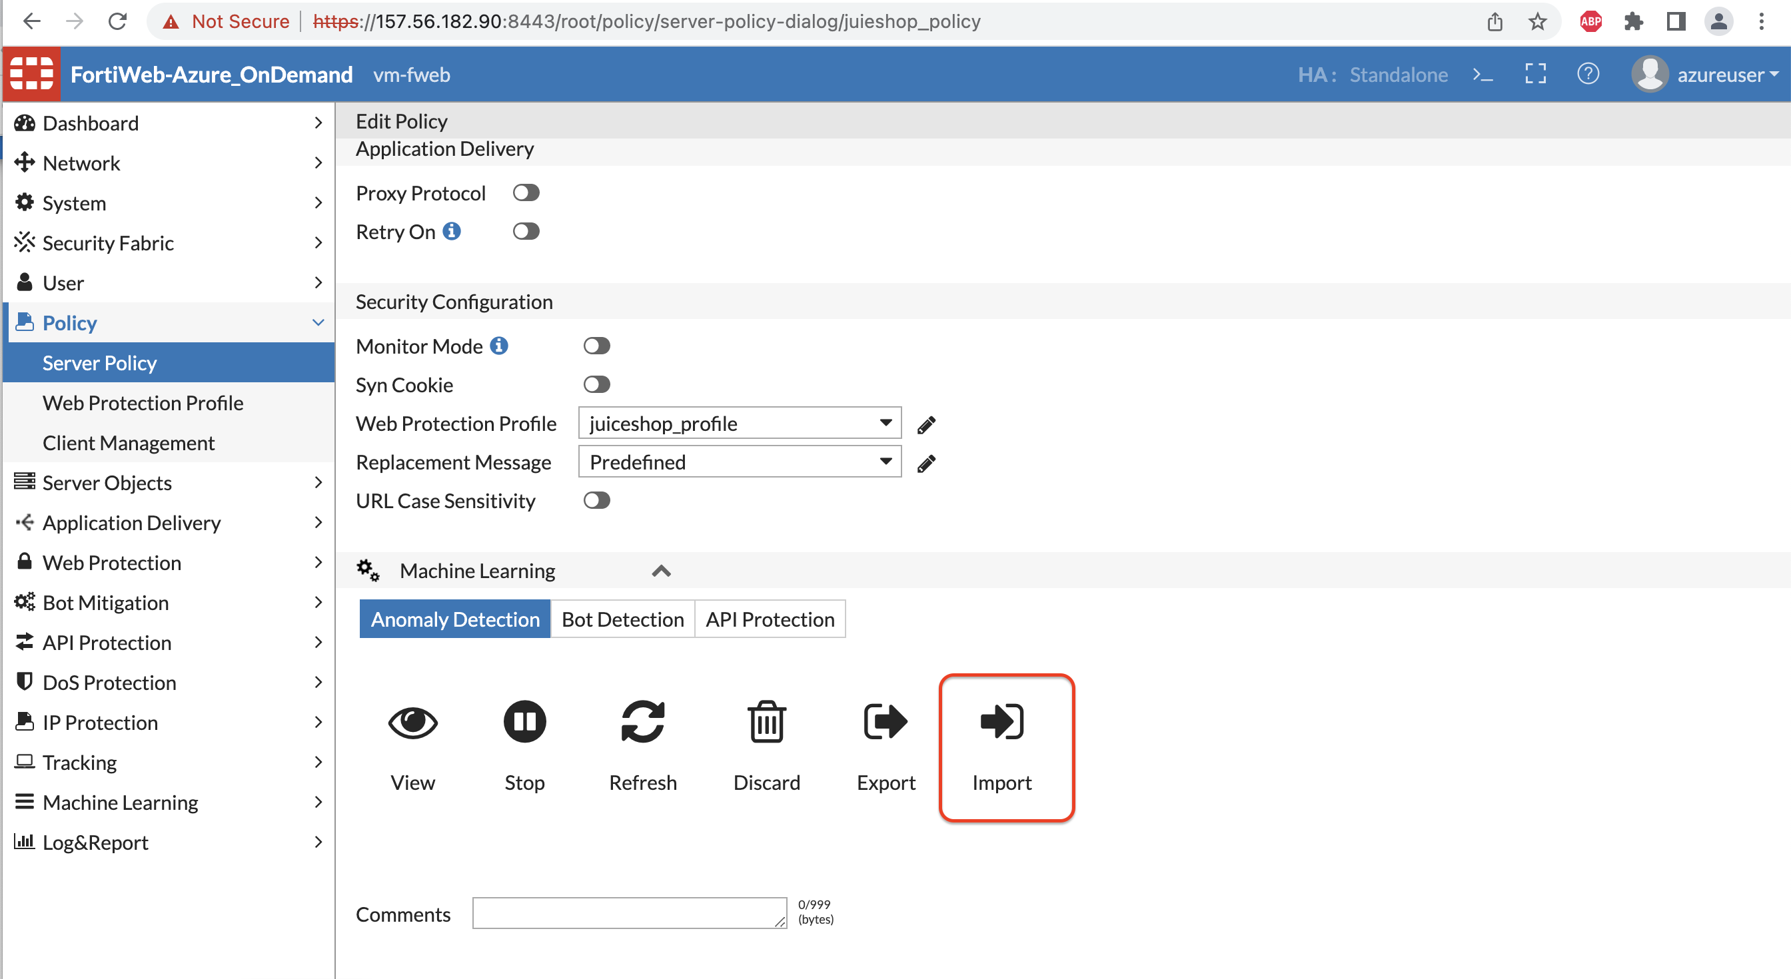
2. For the sake of the time for this lab the .dat file is provided to import the ML model.

Please import the dat file for Anomaly Detection.

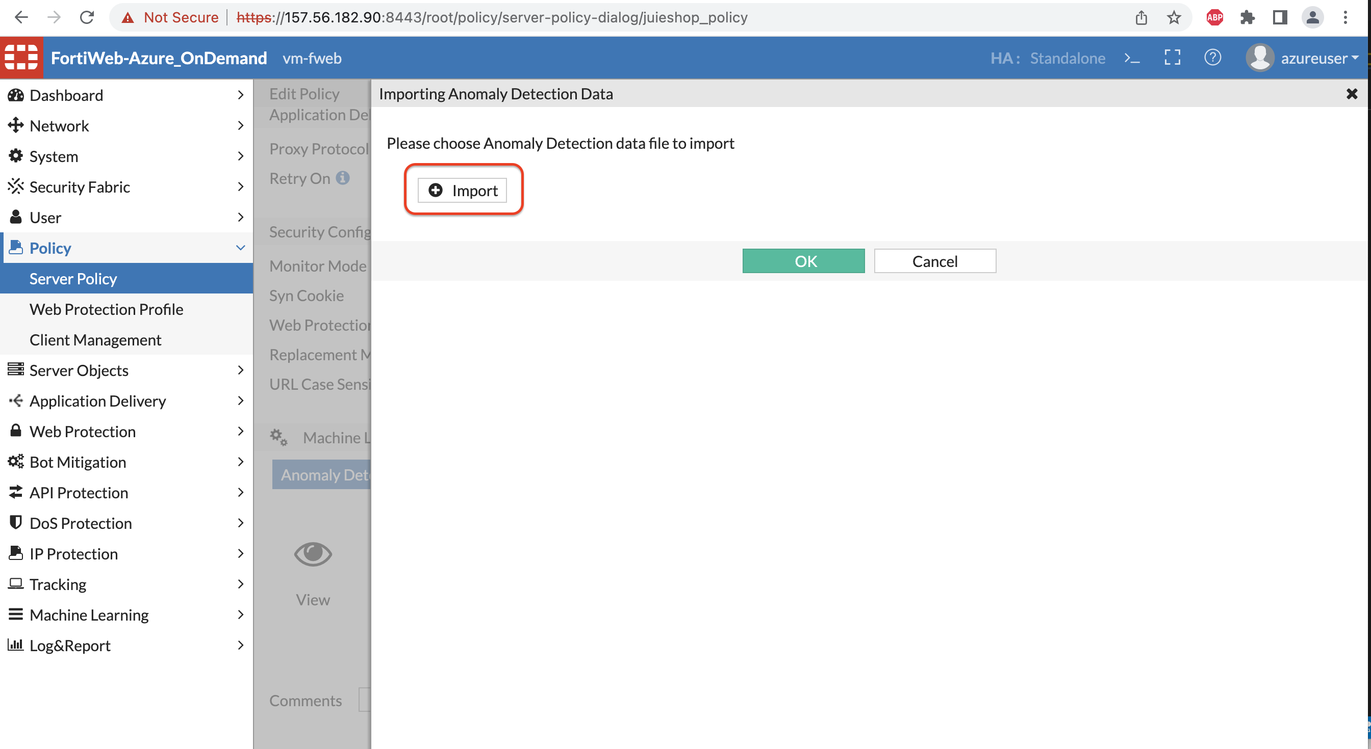

1. You should see the Fortiweb ML AD status to be running.

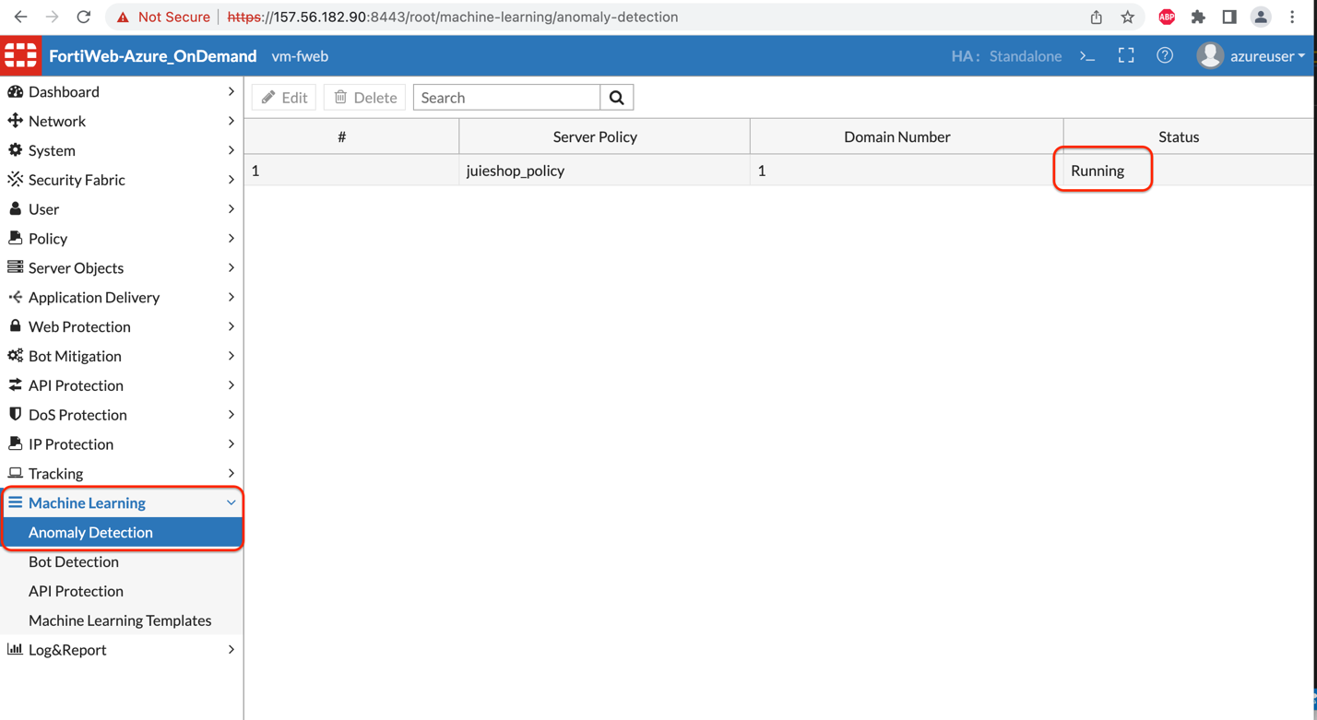

1. Double click on the above rule and click on View Domain data to view more information about the parameters Fortiweb already learned.

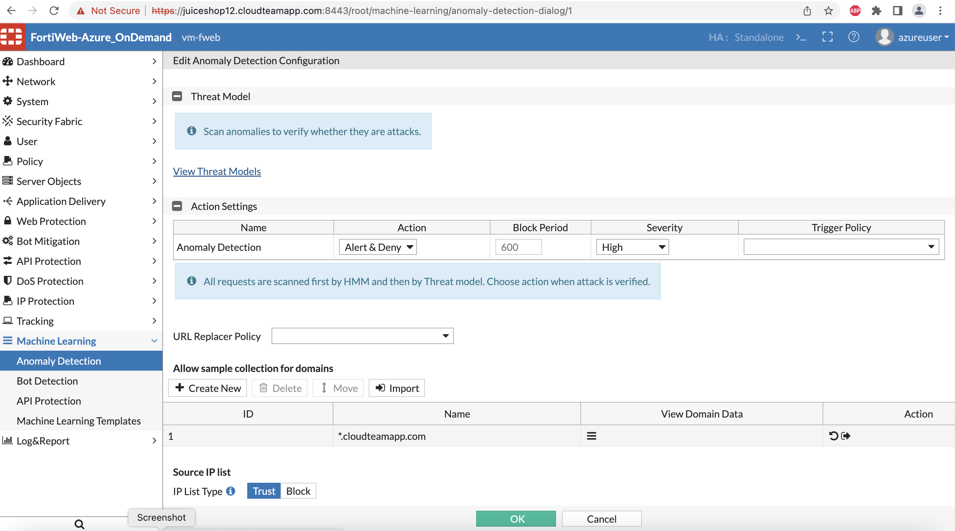

1. Try the SQL lite attack by copy pasting the below URL in the browser or importing the cURL using POSTMAN or making cURL request.

<http://juiceshopX.cloudteamapp.com:3000/rest/products/search?q='))-->

For example: <http://juiceshop12.cloudteamapp.com:3000/rest/products/search?q='))-->

curl --location --request GET 'http://juiceshop12.cloudteamapp.com:3000/rest/products/search?q='\''))--' \

--header 'Content-Type: application/x-www-form-urlencoded' \

1. Check the attack log in Log and Report >> attack log to make sure this attack is being blocked by ML AD on Fortiweb.

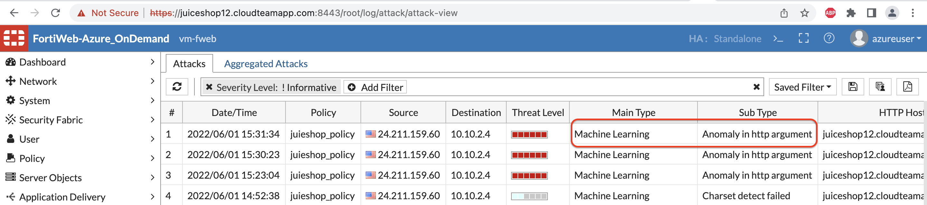

Bot ML:

1. Like the previous step to enable ML AD, it’s now time to enable to Bot Detection on Fortiweb. Double click on the Server policy and click create under Bot detection.

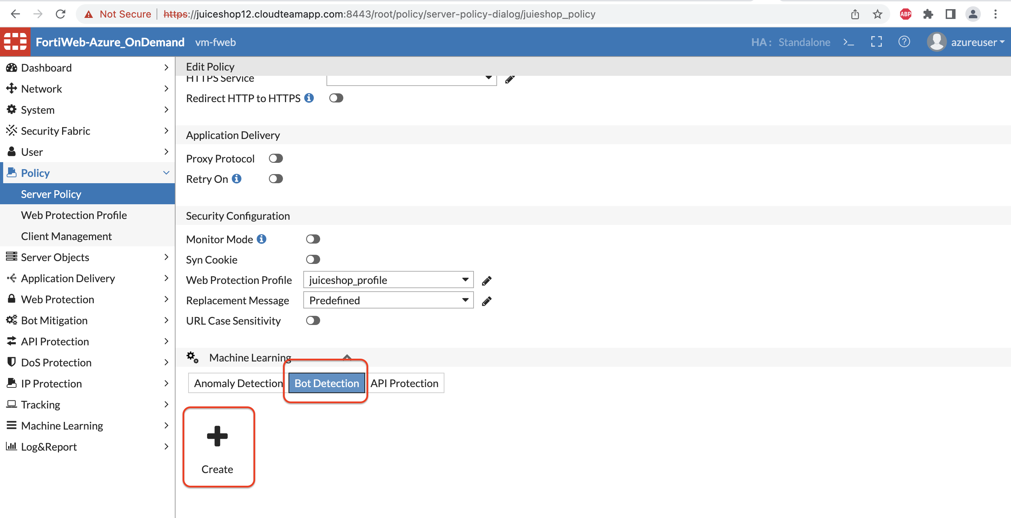

1. You can leave blank for the IP range and click OK.

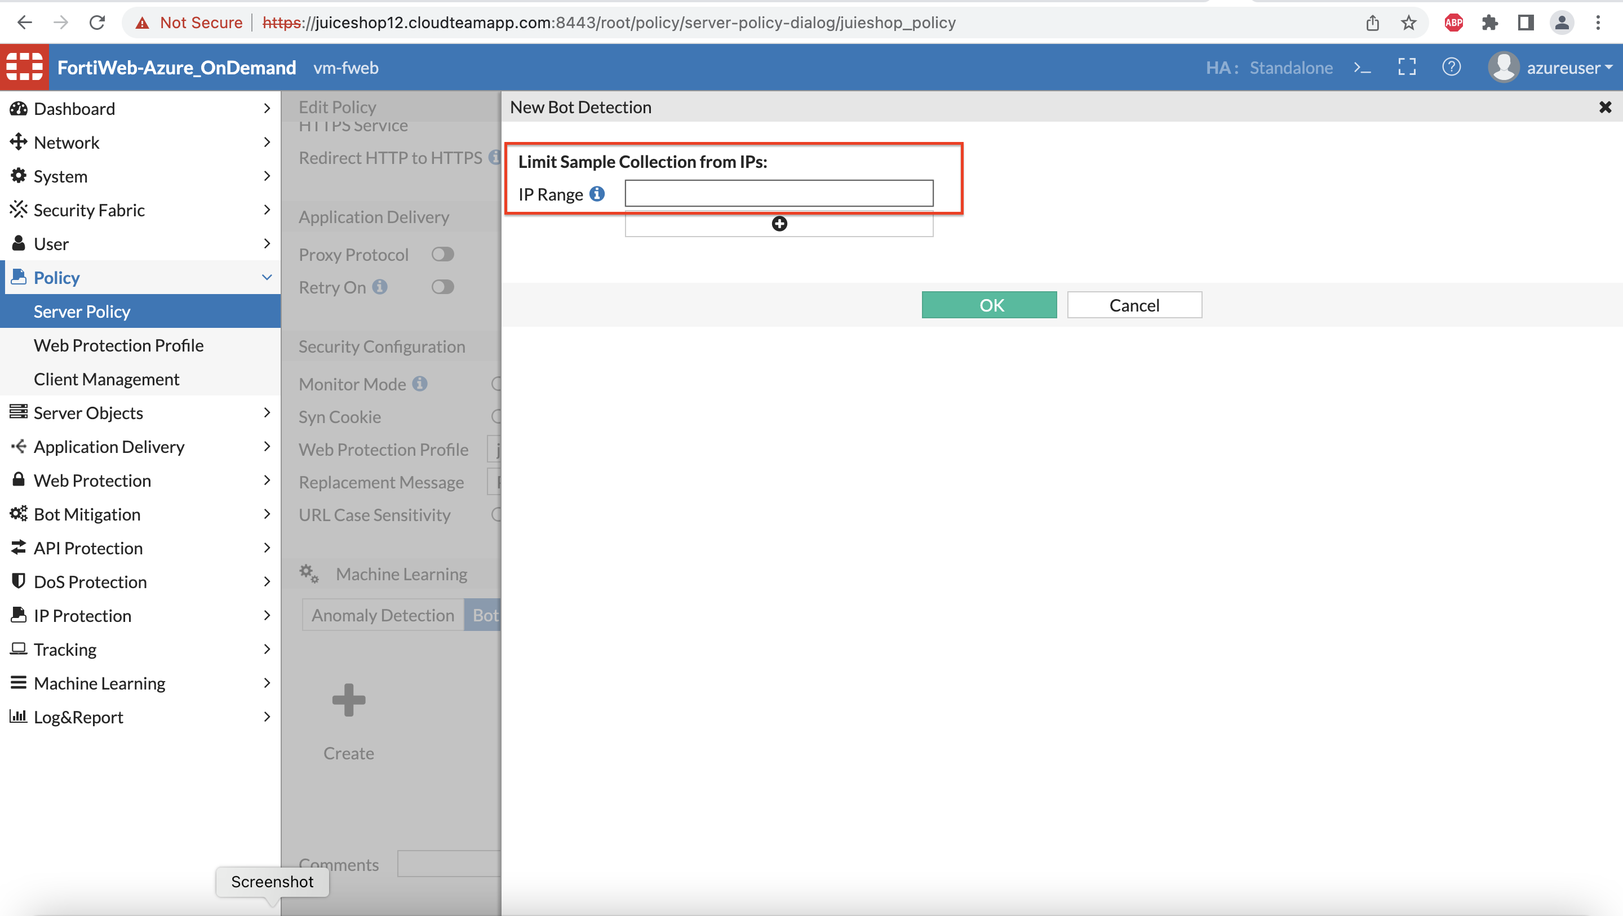

1. For the sake of time, a dat file is provided for you already. Import the dat file for Bot detection for the model to be running.

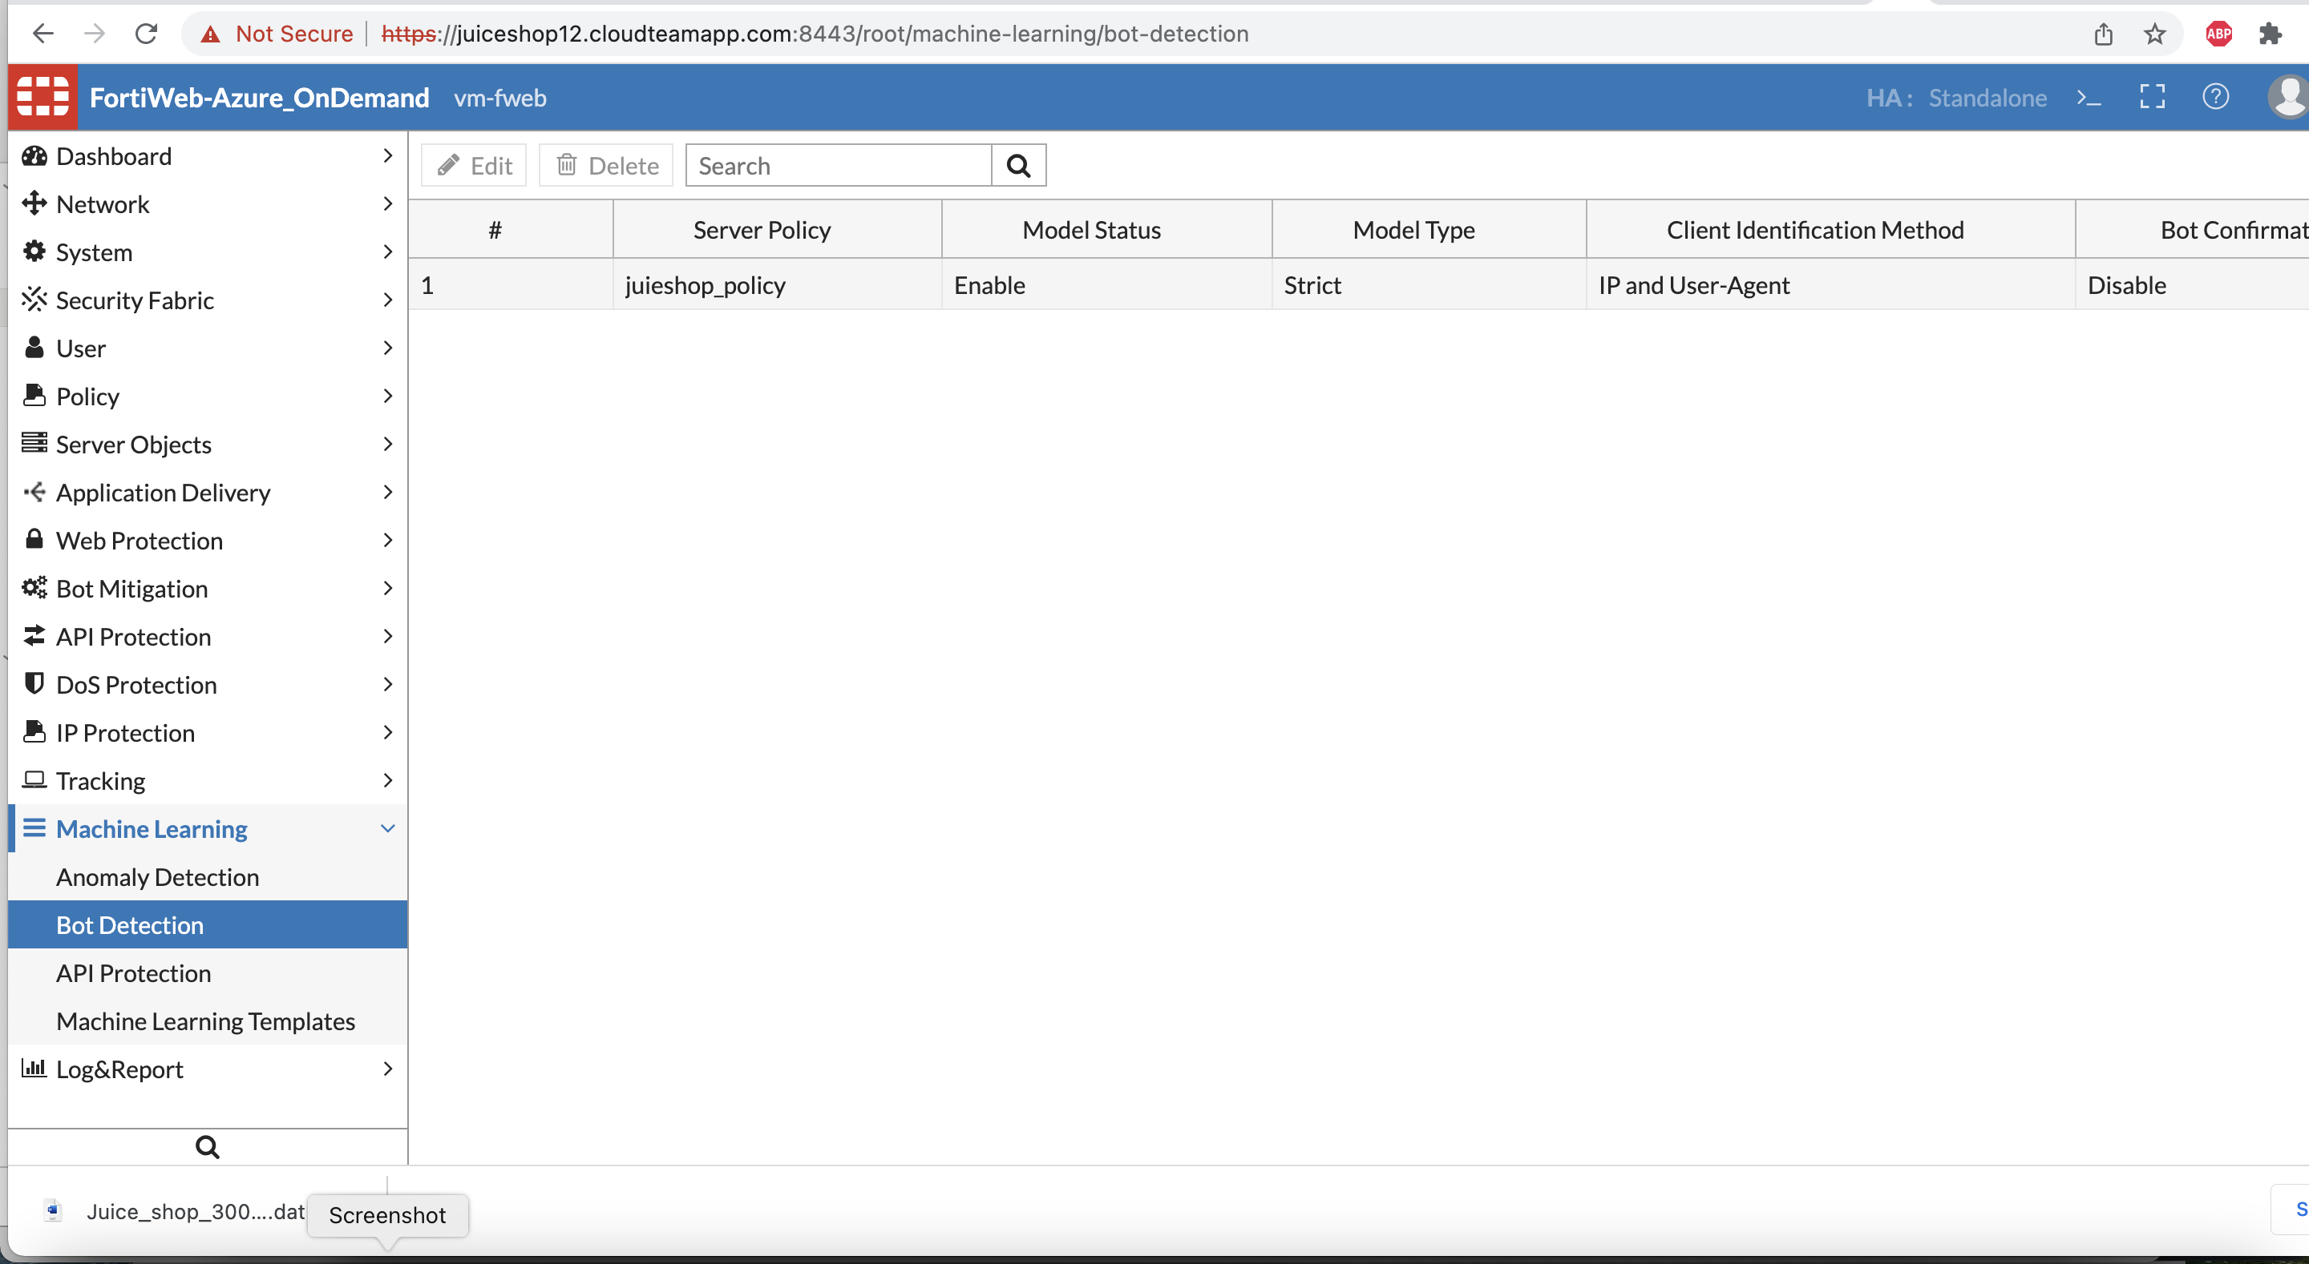

1. Once the file is imported the model status should show ready.

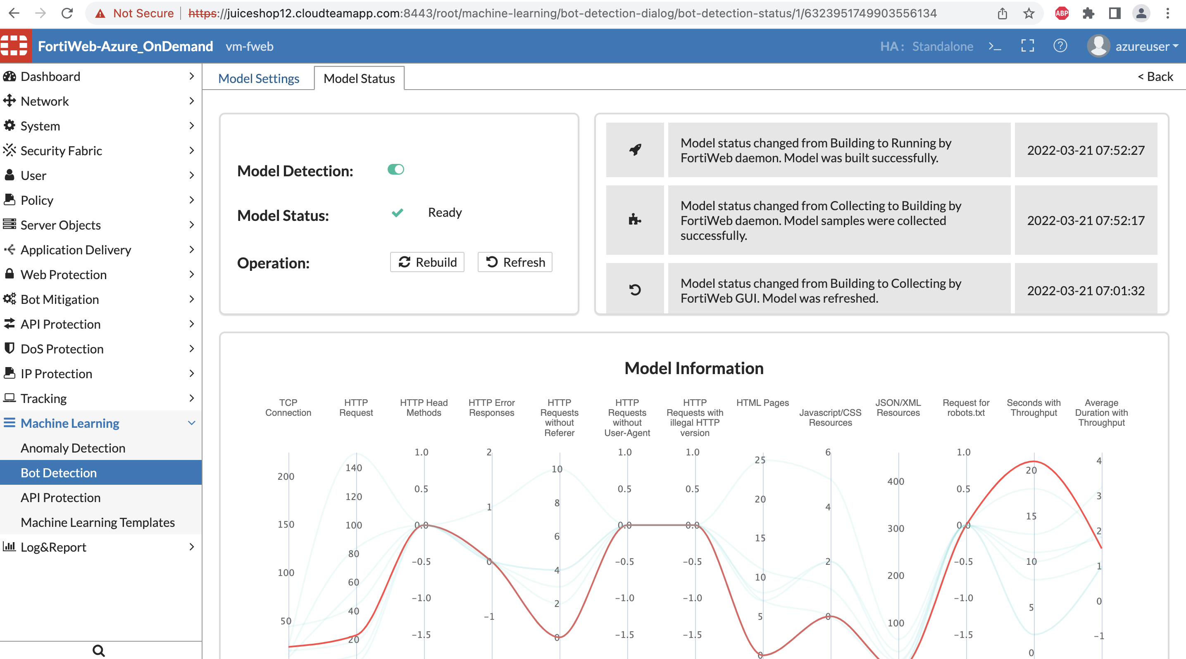

1. Run the Scrape_products.py script again. You can step away to get some coffee while this script is running ☺
2. By the time you will be back you should see the HTML for Fortiweb Block page. This can also be verified by going to Attack log. You should now be able to remember where the attack log is without my help ;)

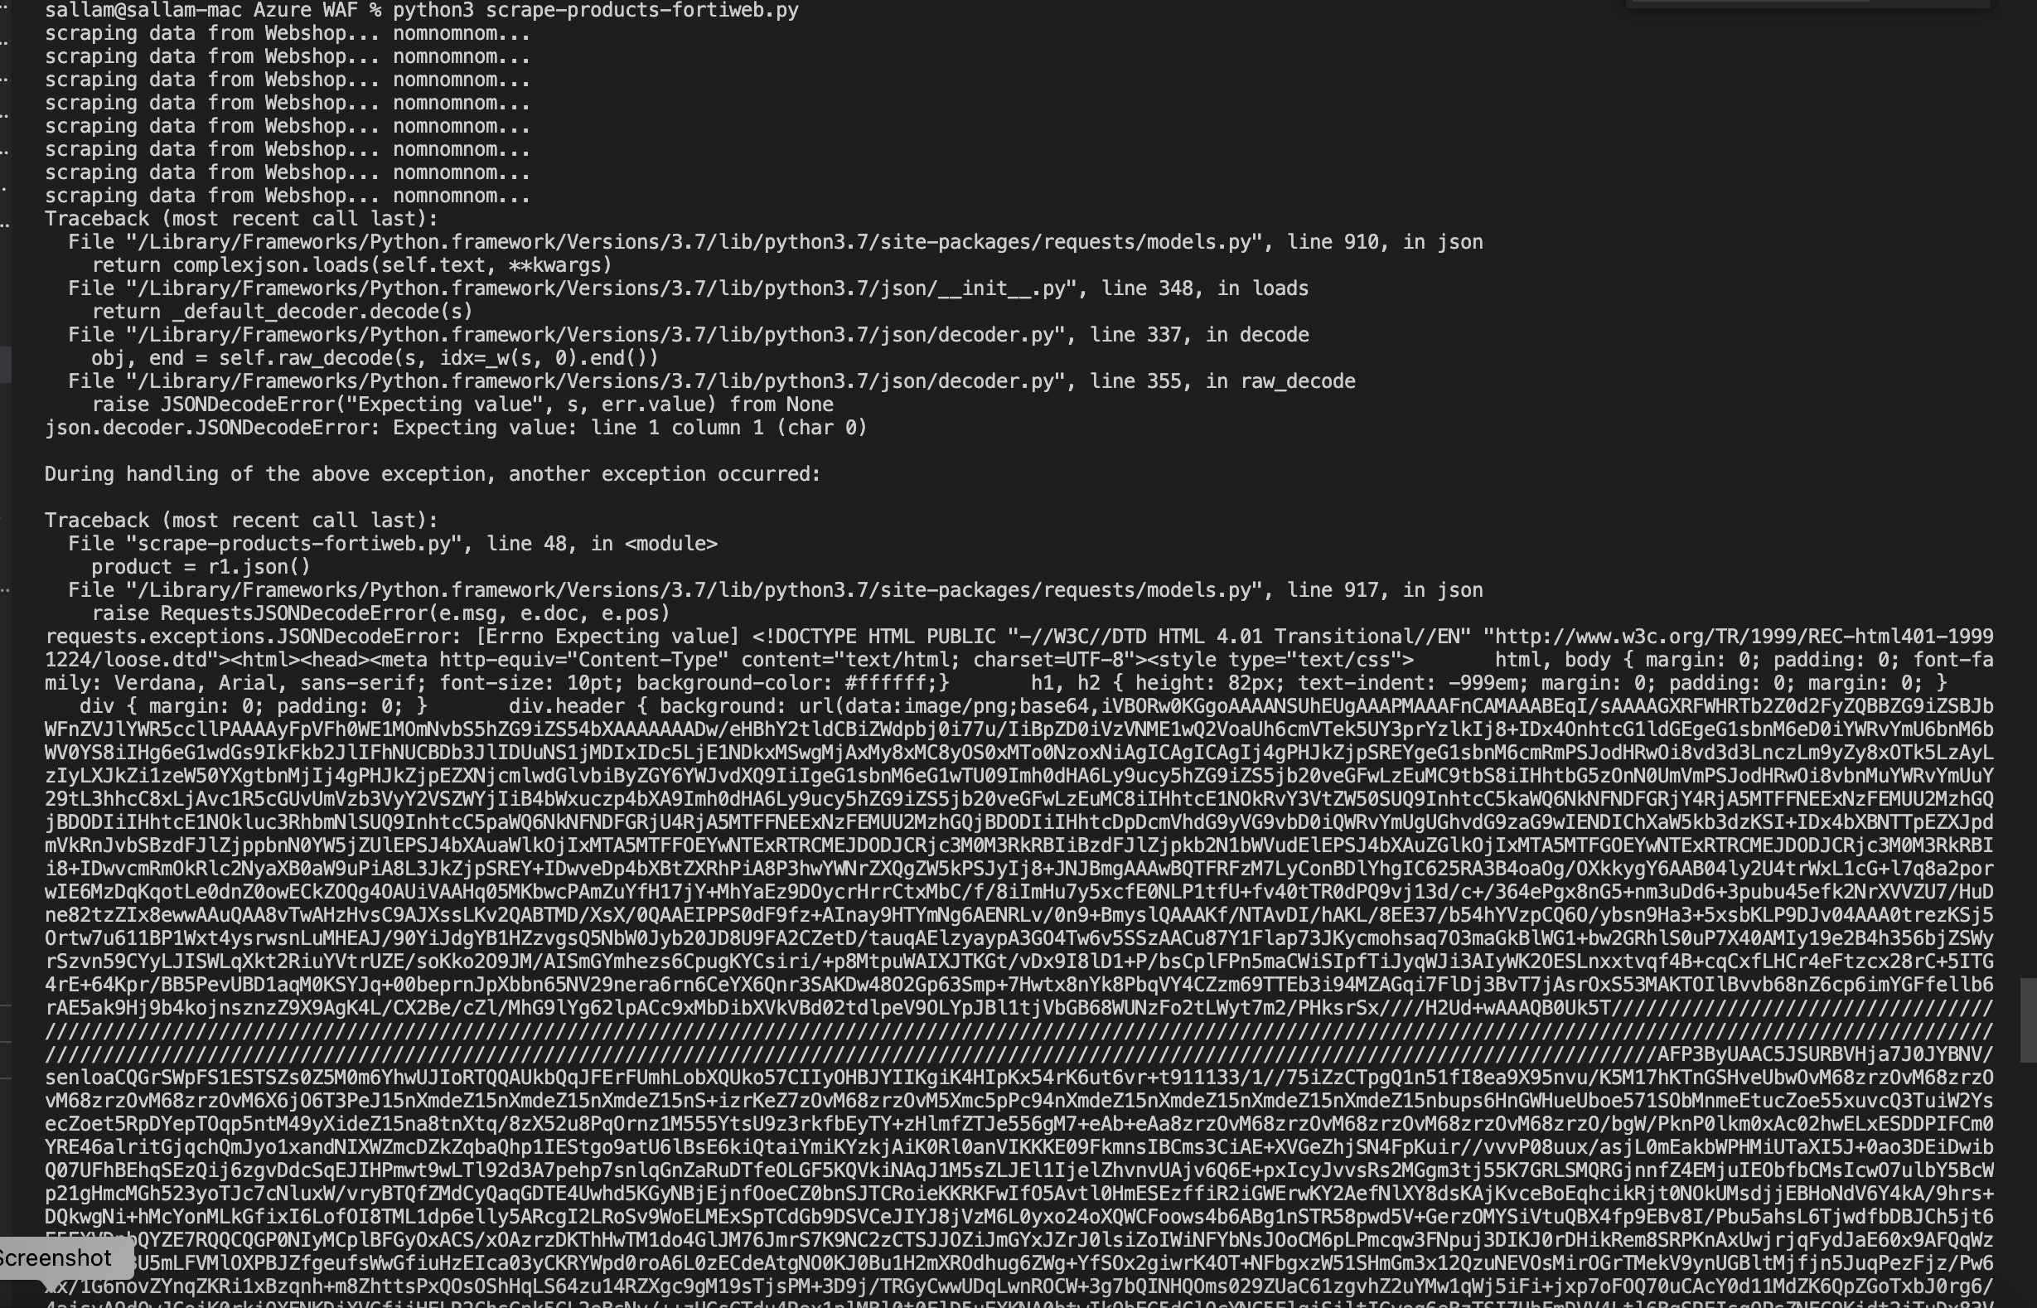

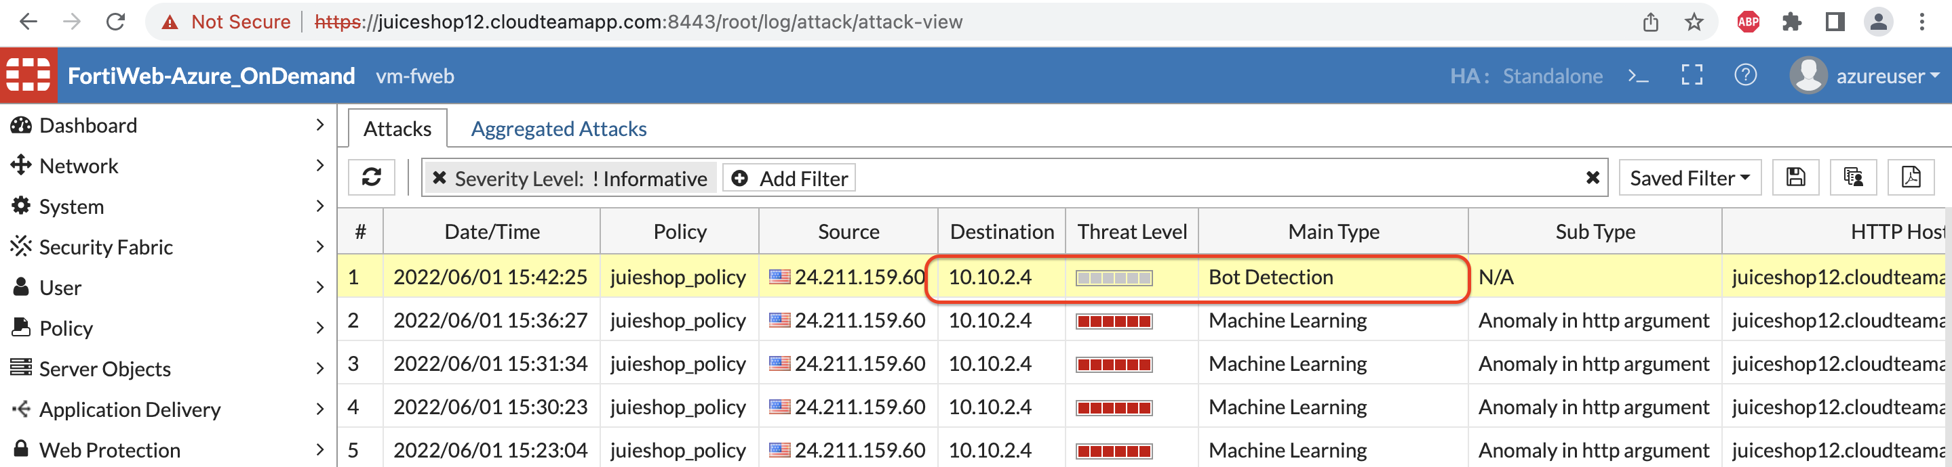

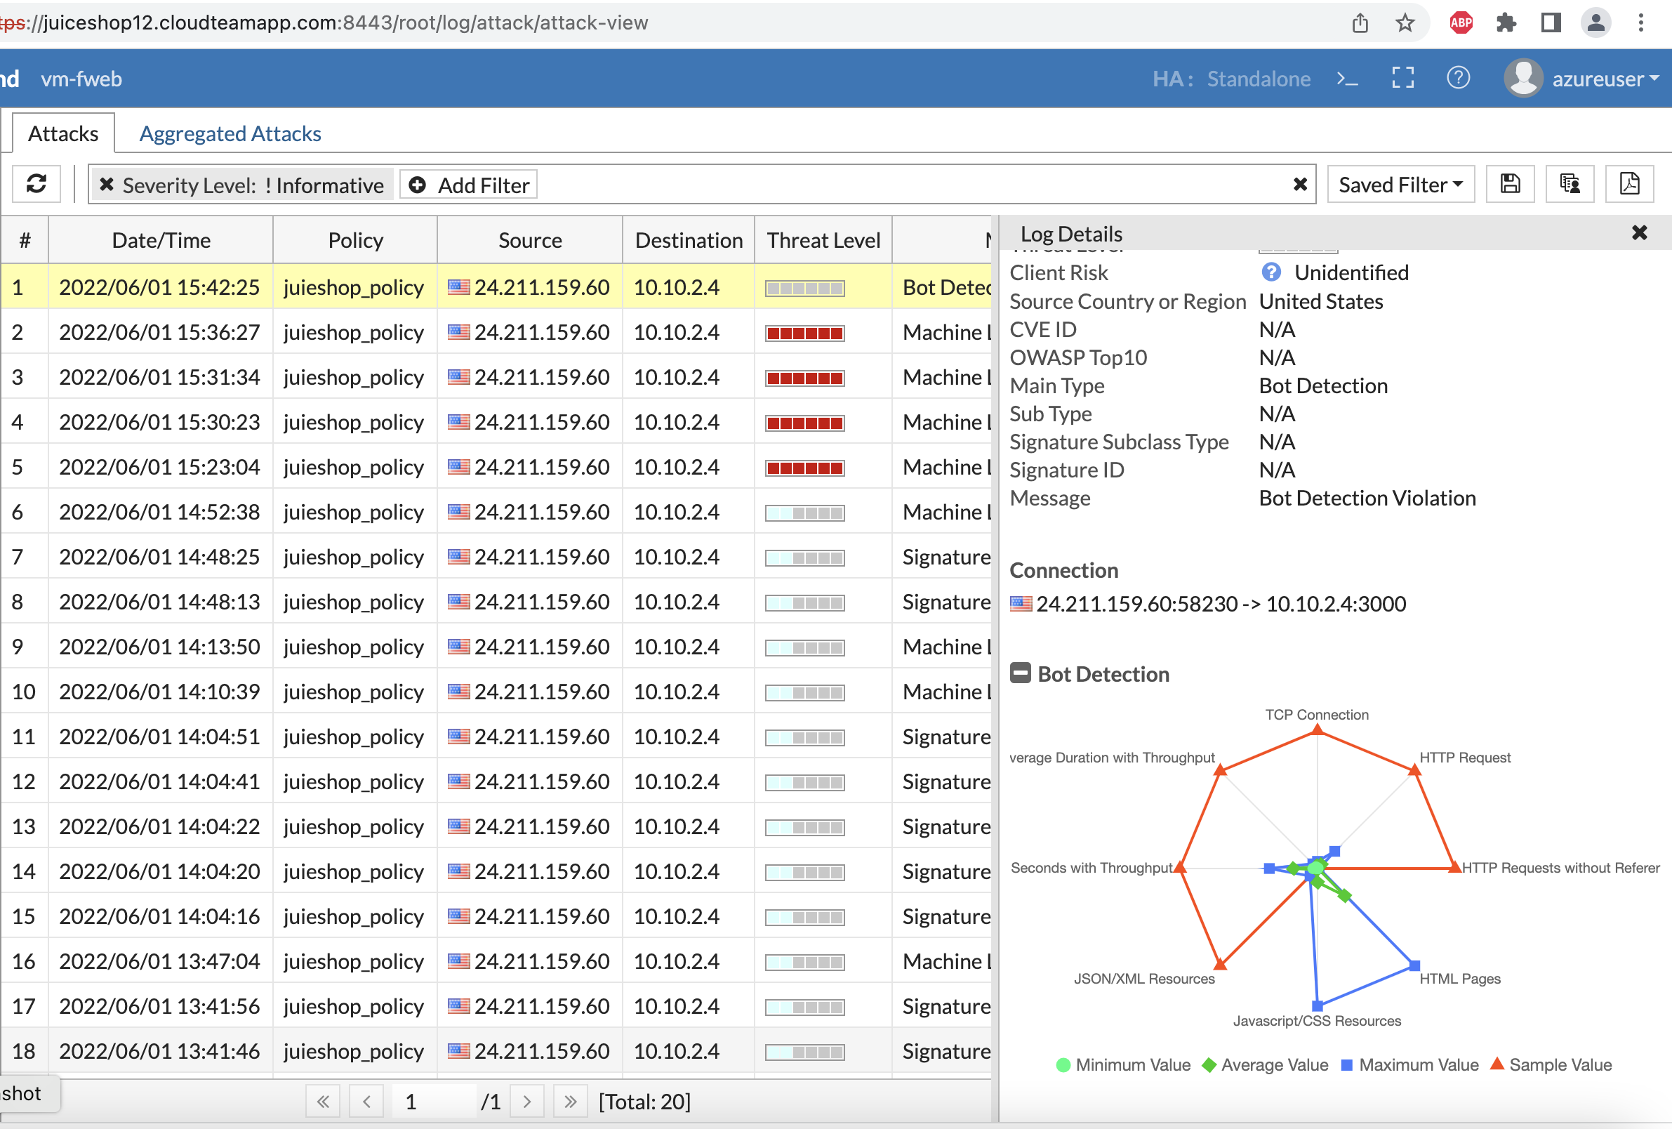

API protection:

1. For ML API protection, you will need to create the API Protection in Server Policy. Try on your own to enable the API protection….

If not help is right here ;)

Server Policy, double click the existing policy and scroll down to API protection.

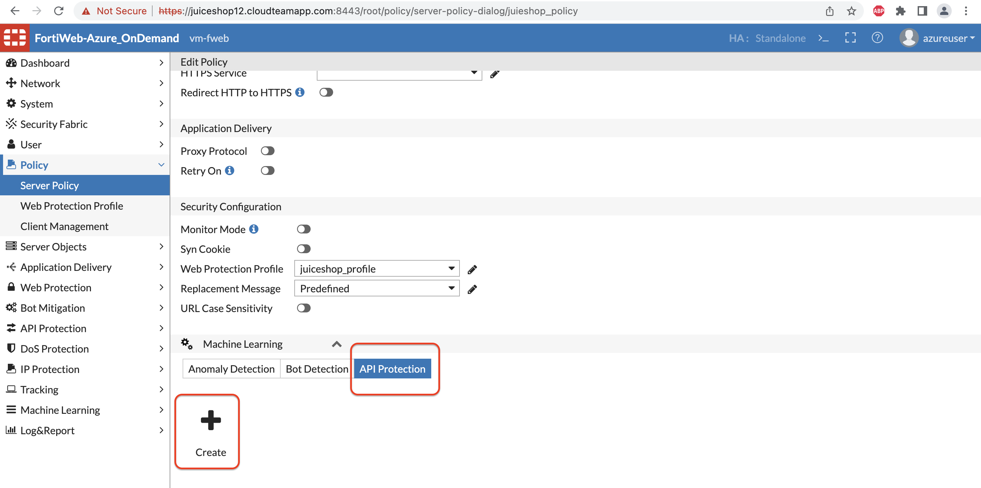

1. Upload the dat file provided for ML API protection.
2. Enter the domain name for the Juice shop. you can also use Wildcard Domain name.

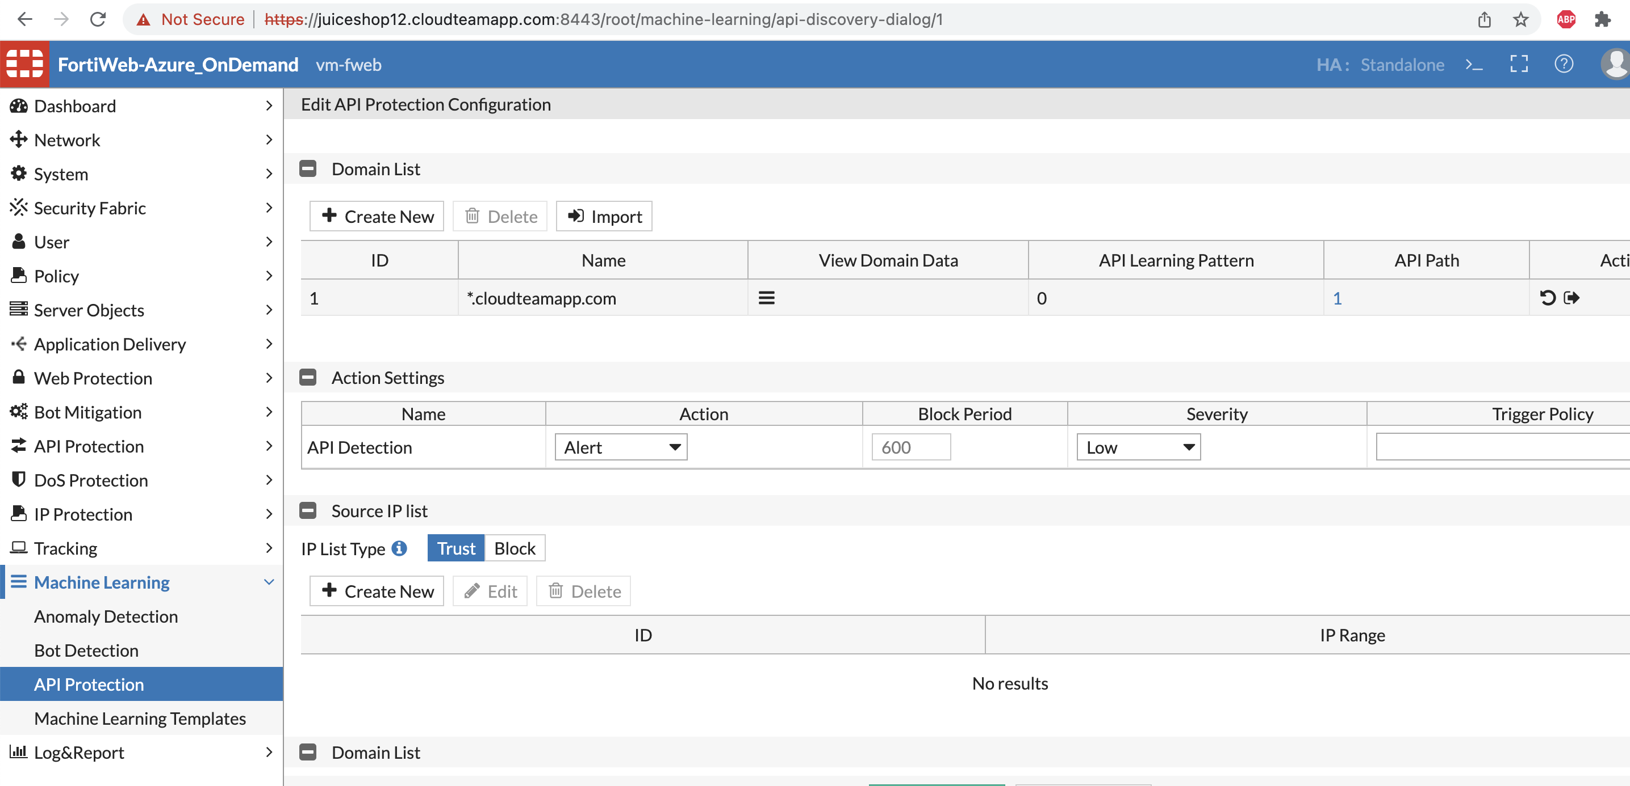

1. Verify by clicking on the domain data and see if at least one URL is in running state. The dat file you uploaded is trained ML model with API call to create users and with body Parameters of type string.

For example, this was the request used to train the API ML model.

curl --location --request POST 'http://juiceshop12.cloudteamapp.com:3000/api/users' \

--header 'Content-Type: application/json' \

--header 'Cookie: cookiesession1=678A3E0D85EB508A4A889B9D45DE60CE' \

--data-raw '{"email": "test2.example.com", "password": “abcdefgh”}'

1. Let’s now generate the attack by running below cURL request or importing on POSTMAN.

curl --location --request POST 'http://juiceshop12.cloudteamapp.com:3000/api/users' \

--header 'Content-Type: application/json' \

--data-raw '{"email": "test23.example.com", "password": 123456789}'

1. Fortiweb will show an attack log with the API body violation since the password you have used is of type String.

